Name

Mathematics Advanced Year 12
Continuous
Random Variables

Book 1 |  | Version: 260709  Feedback:  https://MrDingMaths.com
Contents
Syllabus Content 2
Continuous Random Variables and Relative Frequency 3
Probability Density Functions 6
Calculating Probabilities using Integration 10
Uniform Distributions 13
Mode of a Continuous Distribution 16
Cumulative Distribution Functions 18
Expected Value and Variance 23

Syllabus Content
MAV-12-07 solves problems involving discrete probability distributions, continuous random variables and the normal distribution
Continuous random variables
- Estimate the probability that a continuous random variable falls in some interval using relative frequencies and histograms obtained from data
- Recognise that the probability of a particular value for a continuous random variable is 0 and hence that $P\left(a<X<b\right)=P\left(a≤X<b\right)=P\left(a<X≤b\right)=P\left(a≤X≤b\right)$ since $P\left(X=a\right)=P\left(X=b\right)=0$ when $X$ is a continuous random variable
- Define the cumulative distribution function (CDF), $F\left(x\right)$, as the probability of a random variable, $X$, having values less than or equal to $x$, so $F\left(x\right)=P\left(X≤x\right)$ and $P\left(a≤x≤b\right)=F\left(b\right)-F\left(a\right)$
- Recognise that the cumulative distribution function, $F\left(x\right)$, is non-decreasing for all $x$ in its domain, and graph cumulative distribution functions, given a formula for $F\left(x\right)$, with and without graphing applications
- Define a probability density function (PDF), $f\left(x\right)$, for a random variable $X$ with cumulative distribution function $F\left(x\right)$ as $f\left(x\right)=F^{'}\left(x\right)$ and recognise that $P\left(a<X<b\right)=\int_{a}^{b}{f(x)}dx$
- Recognise the properties of a probability density function: $f\left(x\right)≥0$ for all $x$ in the domain of $f\left(x\right),$ and $\int_{a}^{b}{f\left(x\right)dx}=1$ if the domain of $f\left(x\right)$ is $\left[a,b\right]$, or $\int_{-∞}^{∞}{f\left(x\right)dx}=1$ if the domain of $f\left(x\right)$ is all real $x$
- Apply the properties of a probability density function to solve problems and justify conclusions
- Find the mode from a given probability density function
- Obtain the cumulative distribution function using the formula $F\left(x\right)=\int_{a}^{x}{f\left(t\right)dt}$ where $f\left(x\right)$ is a given probability density function defined on the interval $\left[a,b\right]$
- Determine and use the probability density function $f\left(x\right)=\frac{1}{b-a}$ for a continuous uniform distribution for a random variable $X$ taking values in the interval $\left[a,b\right]$
- Use a cumulative distribution function to calculate the median and quartiles for a continuous random variable
- Find the probability density function from a given cumulative distribution function
- Generate the expression for the expected value of a continuous random variable, $E\left(X\right)=μ=\int_{a}^{b}{xf\left(x\right)dx}$, where the probability density function $f\left(x\right)$ is defined on the interval $\left[a,b\right]$
- Generate the expression for the variance of a continuous random variable, $\text{Var}\left(X\right)=E\left(X^{2}\right)-μ^{2}=\int_{a}^{b}{x^{2}f\left(x\right)dx}-μ^{2}$, where the probability density function $f\left(x\right)$ is defined on the interval $\left[a,b\right]$
- Evaluate the expected value and the variance of a continuous random variable, where the probability density function $f\left(x\right)$ is defined on the interval $\left[a,b\right]$, that involve integration of functions within the scope of the Mathematics Advanced course
- Evaluate the expected value and the variance of a continuous random variable, where the probability density function $f\left(x\right)$ is defined on the interval $\left[a,b\right]$, that involve integration of functions beyond the scope of the Mathematics Advanced course using an online computational application

Continuous Random Variables and Relative Frequency

- Review
- Analyse discrete random variables
$$x$$ | 0 | 1 | 2 | 3 | 4 | 5
$$P(X = x)$$ | 0.1 | 0.2 | 0.3 | 0.25 | 0.05 | 0.1

- $P\left(X=1\right)$  $$0.2$$ | - $P\left(2≤X≤4\right)$  $$0.6$$ | - $P\left(1≤X<4\right)$  $$0.75$$
- $P\left(X=6\right)$  $$0$$ | - $P\left(X≤2\right)$  $$0.6$$ | - $P\left(X<4\right)$  $$0.85$$

- Analyse grouped data
The table shows the times taken, in minutes, to complete a puzzle.
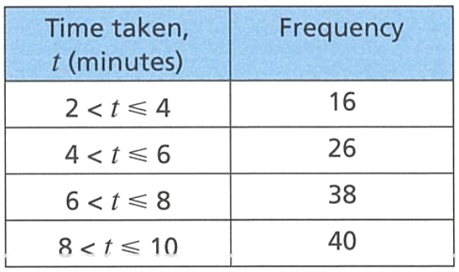

  - Which class interval has the lowest frequency?
$$2<t≤4$$
  - How many people took longer than 8 minutes to complete the puzzle?
40
  - How many people in total completed the puzzle?
120
  - What is the relative frequency for people taking $6<t≤10$ to complete the puzzle?
13/20
- Recall the law of large numbers
The Law of Large Numbers says that as you ………………… the number of trials, the relative frequency gets closer to the t………………… p………………….

- Continuous Random Variables
A continuous random variable can take any value in an interval, not just specific isolated values. Examples include height, mass, temperature, and waiting time.

- Identify Continuous and discrete random variables
- Number of cars in a car park  - Discrete  - Continuous | - Speed of a car as it passes a sensor  - Discrete  - Continuous
- Temperature at noon on a given day  - Discrete  - Continuous | - Number of defective items in a batch  - Discrete  - Continuous
- Height of a student, in centimetres  - Discrete  - Continuous | - Number of students absent on a day  - Discrete  - Continuous
- Time for a Year 7 to swim 50 m  - Discrete  - Continuous | - Score in a 10-question multi-choice quiz  - Discrete  - Continuous
- Mass of a bag of rice  - Discrete  - Continuous | - Number of heads when flipping 3 coins  - Discrete  - Continuous

- $P\left(X=a\right)=0$ for Continuous Random Variables
For a continuous random variable, the probability of any single exact value is 0, because infinitely many values are possible in any interval.
In other words, $P\left(X=a\right)=0$ for all $a$.
The probability that a student in the school is exactly 158.00000… cm is zero.
You can only sensibly ask questions like ‘what is the probability of someone’s height being between 150 and 160 cm; $P\left(150<X<160\right)$?’

Furthermore, because $P\left(X=a\right)=0$ and $P\left(X=b\right)=0$, including or excluding endpoints makes no difference when calculating the probability of a value lying within an interval.
$$P\left(a<X<b\right)=P\left(a≤X≤b\right)$$

- Example Estimate relative frequencies from class intervals
The waiting times (minutes) for 40 patients at a clinic are summarised below:
 | - Verify the relative frequencies sum to 1.  $$0.1+0.3+0.4+0.15+0.05=1$$  - Estimate $P\left(X<6\right).$  $$P\left(X<6\right)=0.1+0.3 \\ =0.4$$  - Estimate $P\left(3≤X<12\right).$  $$P\left(3 ≤ X < 12\right)=0.3+0.4+0.15 \\ =0.85$$
  Time | Freq | Relative Freq
  $$0 ≤ t < 3$$ | $$4$$ | $$0.10$$
  $$3 ≤ t < 6$$ | $$12$$ | $$0.30$$
  $$6 ≤ t < 9$$ | $$16$$ | $$0.40$$
  $$9 ≤ t < 12$$ | $$6$$ | $$0.15$$
  $$12 ≤ t < 15$$ | $$2$$ | $$0.05$$

- Guided Practice
- Using the same table above, find  $$P\left(X<9\right)$$  0.8 | - Using the same table above, find  $$P\left(3≤X<15\right)$$  0.9
A new sample has classes [0, 4), [4, 8), [8, 12), [12, 16)
with relative frequencies 0.08, 0.42, 0.36, 0.14.

- Find $P\left(X<8\right)$  0.5 | - Find $P\left(4≤X<12\right)$  0.78

Foundation
- State whether each random variable is discrete or continuous.
  - The size of T-shirts worn by people
Discrete
  - The speed of cars as they pass a certain point
continuous
  - The volume of water in a dam
continuous
  - The number of seats on an aeroplane
discrete
  - The weight of babies born in August
Continuous
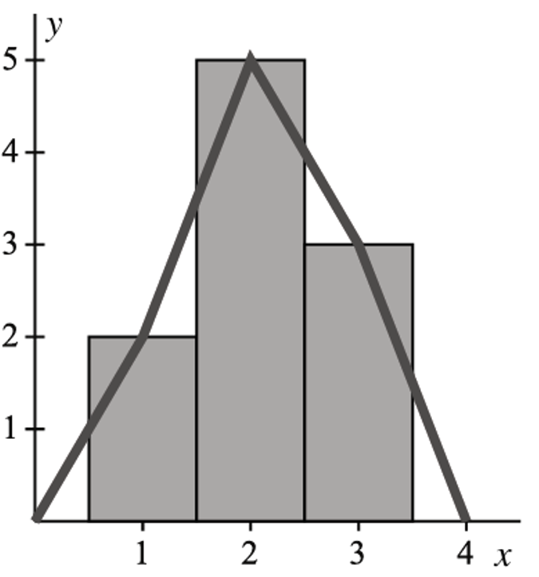
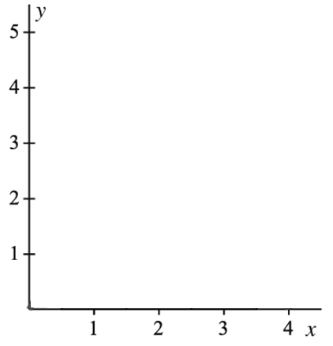
- A simple experiment generated the following data:
  - Construct a frequency histogram and frequency polygon
(join centres of data points back to horizontal axis).

Score $x$ | 1 | 2 | 3
Frequency $f$ | 2 | 5 | 3

  - Calculate the total area of the histogram rectangles.
Total area = $1(2)+1(5)+1(3)=10$
  - Calculate the area under the frequency polygon.
Area under polygon = $10$ (triangles cut above fit into gaps below)
  - What do you notice?
Both areas equal the total frequency.
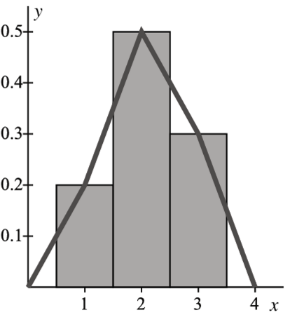
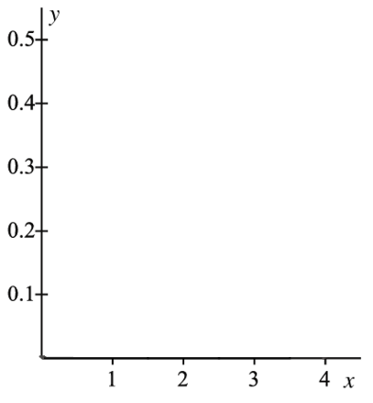
  - Add a row of relative frequencies (divide by total $n = 10$).
Score $x$ | 1 | 2 | 3
Frequency $f$ | 2 | 5 | 3
Rel. Freq

$$0.2,0.5,0.3$$
  - Construct a relative frequency histogram and polygon.
  - Calculate the total area of the histogram rectangles.
$$Total area = 1(0.2)+1(0.5)+1(0.3)=1$$
  - Calculate the area under the relative frequency polygon.
Area under polygon = $1$
  - What do you notice?
Both areas are the sum of the relative frequencies, 1
  - What is the relationship between relative frequencies and the probabilities $P(X = x)$, according to the Law of Large Numbers?
With a large enough dataset, the relative frequency is an accurate experimental estimate of the theoretical probability.
- The number of cars owned per household in a suburb is recorded from census data.
Results are shown in a relative frequency histogram.
(Relative frequencies equal probabilities since this is a population.)
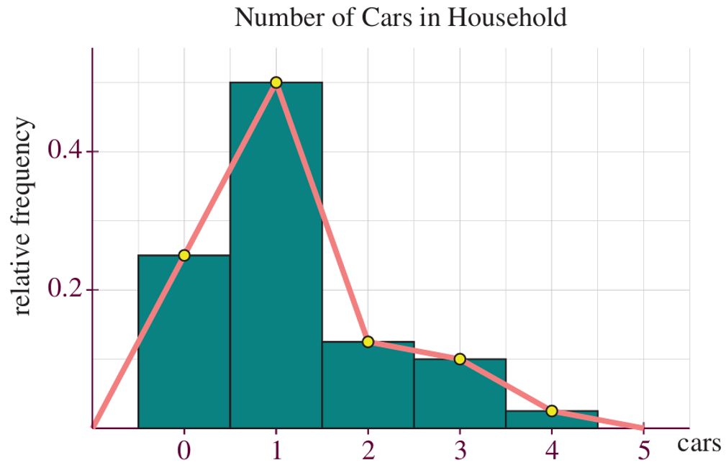

  - What fraction of households have no cars?
$$P(\text{0 cars})=\frac{1}{4}$$
  - What fraction of households have fewer than 2 cars?
$$P(\text{fewer than 2})=P(0)+P(1)=\frac{3}{4}$$
  - What is the probability that a randomly selected household has three cars?
$$P(\text{3 cars})=0.1$$
  - Planners advise additional on-street parking if more than 40% of households have 3 or more cars. Will they advise additional parking?
$P(\text{3 or more})=0.10+0.025=0.125=12.5\%<40\%$.
Planners will not advise additional parking.
  - Complete the probability distribution table $P(X=x)$ using the histogram.
$$x$$ | 0 | 1 | 2 | 3 | 4
$$P\left(X=x\right)$$

$0.25$, $0.50$, $0.125$, $0.10$, $0.025$
  - Show the sum of probabilities is 1. How does this relate to the histogram area?
Sum = $0.25+0.5+0.125+0.1+0.025=1$.
The area of each rectangle = $\text{width}×\text{height}=1×\text{relative frequency}=\text{probability}$.
Total area = sum of probabilities = $1$.
  - Explain why the area under the relative frequency polygon equals the area of the histogram.

Each triangle above the polygon (cut off from a bar) fits into the gap below the polygon on the other side of that same bar’s edge.
Total area is unchanged.
  - Show the mean number of cars per household is 1.15.

$E(X)=0(0.25)+1(0.5)+2(0.125)+3(0.1)+4(0.025)=0.5+0.25+0.3+0.1=1.15$.
This is a population average: for a large number of households, the total cars divided by number of households approaches $1.15$.
  - For a street of 100 households, how many cars in total would you expect?
Are the assumptions reasonable?
Expected cars = $100×1.15=115$.
Assumption: the street’s car-ownership distribution matches the suburb.
This may not hold, streets near train stations or in wealthier areas may differ.

  - Complete the cumulative probability table $P\left(X ≤ x\right)$.
$$x$$ | 0 | 1 | 2 | 3 | 4
$$P\left(X≤x\right)$$
$0.25$, $0.75$, $0.875$, $0.975$, $1$
  - Using horizontal lines at 0.25, 0.5, 0.75, find quartiles Q₁, Q₂, Q₃.
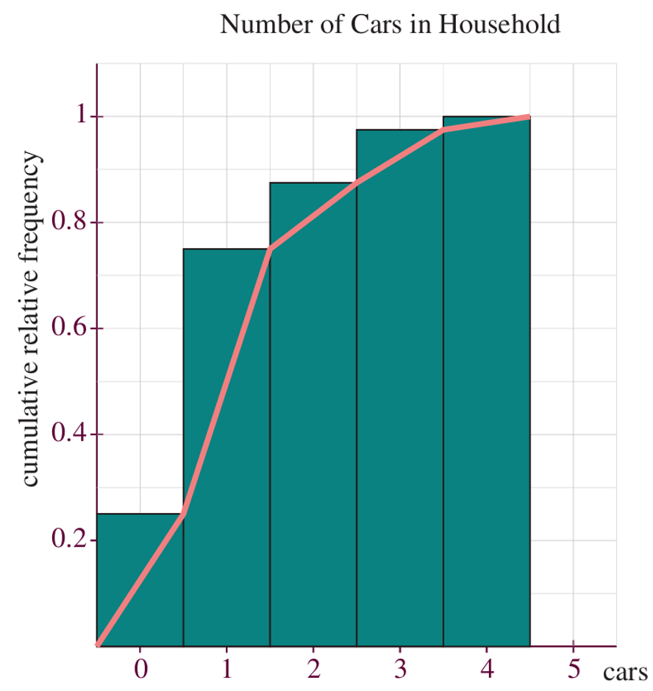

$Q_{1}$ at $P=0.25$ gives $x≈0.5$,
$Q_{2}$ at $P=0.5$ gives $x=1$,
$Q_{3}$ at $P=0.75$ gives $x≈1.5$.

Probability Density Functions

- Review
- Integrate polynomials
$$\int_{2}^{5}{4x+1}dx$$ | $$\int_{0}^{4}{\frac{3}{12}\left(4x+1\right)}dx$$

- Identify sign of a function
Find the domain for which $f\left(x\right)>0$

- $f\left(x\right)=2-x$ | - $f\left(x\right)=x^{2}-9$
- $f\left(x\right)=$ $\frac{x}{8}$ | - $f\left(x\right)=$ $\frac{3x^{2}}{32}$

- Probability Density Functions
A probability density function (PDF) is a smooth curve that models the distribution of a continuous random variable. You can think of it as a relative frequency histogram where the class widths have been made infinitely narrow.
For example, imagine we measured the heights of every year 12 girl in the state:
Relative frequency histogram, range 150 – 190 cm, grouped in 4 classes of 10 cm width.
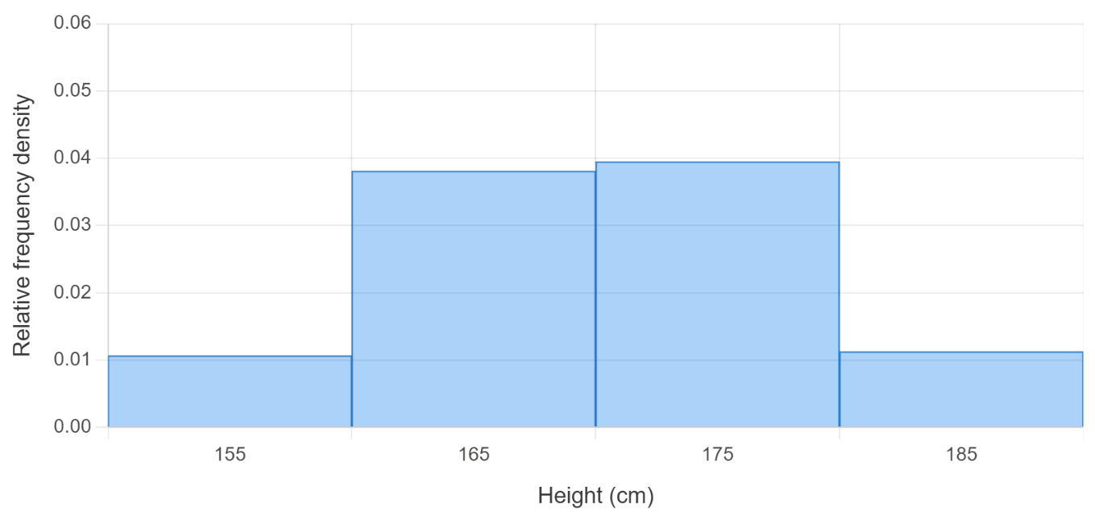

10 classes of 4 cm width:
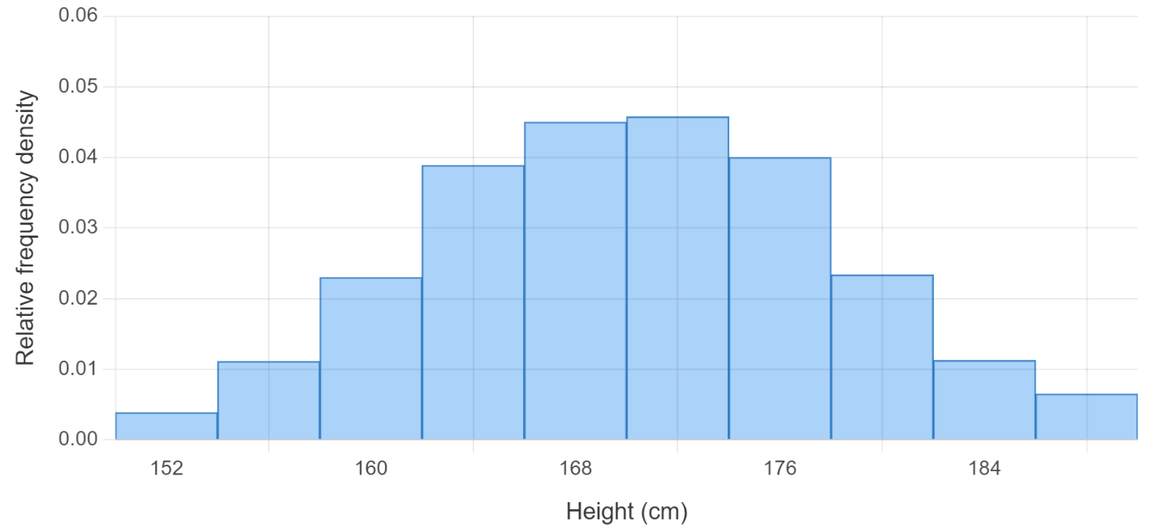

80 classes of 0.5 cm width:
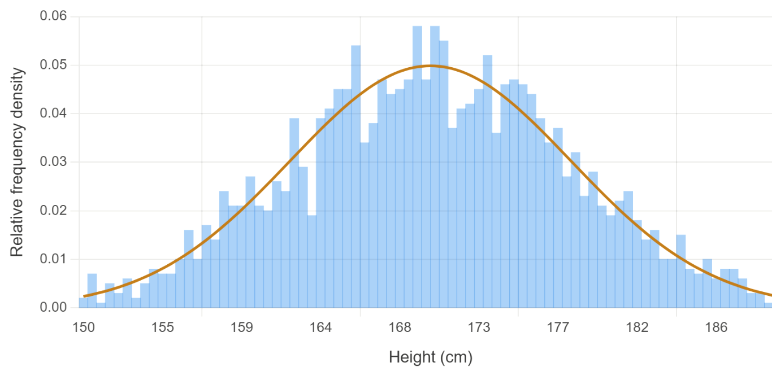

The area under the curve between any two values equals the probability that the variable falls in that interval.

- Verifying Probability Density Functions
A function $f\left(x\right)$ is a PDF in the domain $\left[a,b\right]$ if and only if:
$$1. f\left(x\right)≥ 0 for all x in \left[a, b\right]$$
$$2. \int_{a}^{b}{f\left(x\right)}dx=1$$

- Example Determine whether function is a probability density function
Determine whether the function is a valid probability density function.
$$f\left(x\right)=\left\{\begin{aligned}\frac{x}{8} 0≤x≤4 \\ 0 otherwise\end{aligned}\right.$$
$$1. f\left(x\right)≥ 0 for all x in \left[a, b\right]:$$  $$\frac{x}{8}≥0 for x≥0,$$  $$∴f\left(x\right)=\frac{x}{8}≥0 for 0≤x≤4$$ | $$2. \int_{a}^{b}{f\left(x\right)}dx=1$$  $$\int_{0}^{4}{\frac{x}{8}}dx={\left[\frac{x^{2}}{16}\right]}_{0}^{4}=\frac{16}{16}-0=1$$  $∴$ area under the curve in given region is 1.
In $\left[0,4\right],f\left(x\right)$ is always positive and its integral is 1. Therefore, it is a PDF.

- Guided Practice
Determine whether these functions are valid PDFs
$$f\left(x\right)=\frac{x}{18} on \left[0,6\right]$$  yes | $$f\left(x\right)=\frac{3x^{2}}{26} on \left[1,3\right]$$  yes
$f\left(x\right)=x^{2}-3 on \left[0,3\right]$  No, not always positive | $$f\left(x\right)=x-1 on \left[1,3\right]$$  No, integral not 1

- Key Ideas
- A PDF must satisfy two conditions: $f\left(x\right)≥0$ for all $x$ in the domain, and the integral over the domain equals …………………
- Example Solve problems involving finding a constant in a PDF
A continuous probability distribution function has the function $f\left(x\right)=ax^{2}$ defined on $\left[1, 4\right].$
Find the value of $a$.
$$\int_{1}^{4}{ax^{2}}dx=1 \\ a{\left[\frac{x^{3}}{3}\right]}_{1}^{4}=1 \\ a\left(\frac{64}{3}-\frac{1}{3}\right)=1 \\ 21a=1 \\ a=\frac{1}{21}$$

- Guided Practice
Find the value of the constant if $f\left(x\right)$ is a valid PDF in the given domain.
- $f\left(x\right)=ax^{2}$ on $\left[0, 3\right]$  $$\frac{1}{9}$$ | - $f\left(x\right)=ax^{3}$ on $\left[1, 4\right]$  $$\frac{4}{255}$$
- $f\left(x\right)=kx$ on $\left[2, 6\right]$  $$\frac{1}{16}$$ | - $f\left(x\right)=ae^{x}$ on $\left[0, 2\right]$  $$\frac{1}{e^{2}-1}$$

- Key Ideas
- The area under a probability density function must sum to ………, this means the integral over the domain must also equal …………
- To find an unknown constant in a PDF, set the integral over the domain to equal ……

Foundation
- Which of the following functions describe continuous probability distributions?
  - $f(x)=0.2$ in the domain $[1, 6]$
$f\left(x\right)$ always positive
$$\int_{1}^{6}{0.2} dx = 0.2\left(5\right)= 1, f\left(x\right)≥ 0$$
Valid PDF.
  - $f\left(x\right)=$ $\frac{x}{12}$ in the domain $[0, 6]$
$f\left(x\right)$ always positive when $x>0$
$$\int_{0}^{6}{\left(\frac{x}{12}\right)}dx = {\left[\frac{x^{2}}{24}\right]}_{0}^{6}=\frac{3}{2}≠ 1$$
Not a PDF.

  - $f\left(x\right)=$ $\frac{x^{3}}{324}$ for $0 ≤ x ≤ 3$
$f\left(x\right)$ always positive for $x>0$
$$\int_{0}^{3}{\left(\frac{x^{3}}{324}\right)}dx = {\left[\frac{x^{4}}{1296}\right]}_{0}^{3}=\frac{81}{1296}=\frac{1}{16}≠ 1$$
Not a PDF.
  - $f\left(x\right)=$ $\frac{x^{2}}{21}$ in the interval $1 ≤ x ≤ 4$
$f\left(x\right)$ always positive
$$\int_{1}^{4}{\left(\frac{x^{2}}{21}\right)}dx = {\left[\frac{x^{3}}{63}\right]}_{1}^{4}=\frac{63}{63}= 1, f\left(x\right)≥ 0$$
Valid PDF.
  - $f\left(x\right)=$ $\frac{x}{8}$ for $1 ≤ x ≤ 8$
$f\left(x\right)$ always positive for $x>0$
$$\int_{1}^{8}{\left(\frac{x}{8}\right)}dx = {\left[\frac{x^{2}}{16}\right]}_{1}^{8}=\frac{63}{16}≠ 1$$
Not a PDF.

- Given the continuous probability distribution $f(x) = kx³$ for $0 ≤ x ≤ 5$, 0 for all other $x$, find the value of $k$.

$$\int_{0}^{5}{\left(kx^{3}\right)}dx = k{\left[\frac{x^{4}}{4}\right]}_{0}^{5}=\frac{625k}{4}= 1$$
$$k =\frac{4}{625}$$

- Which of the following graphs are probability density functions?
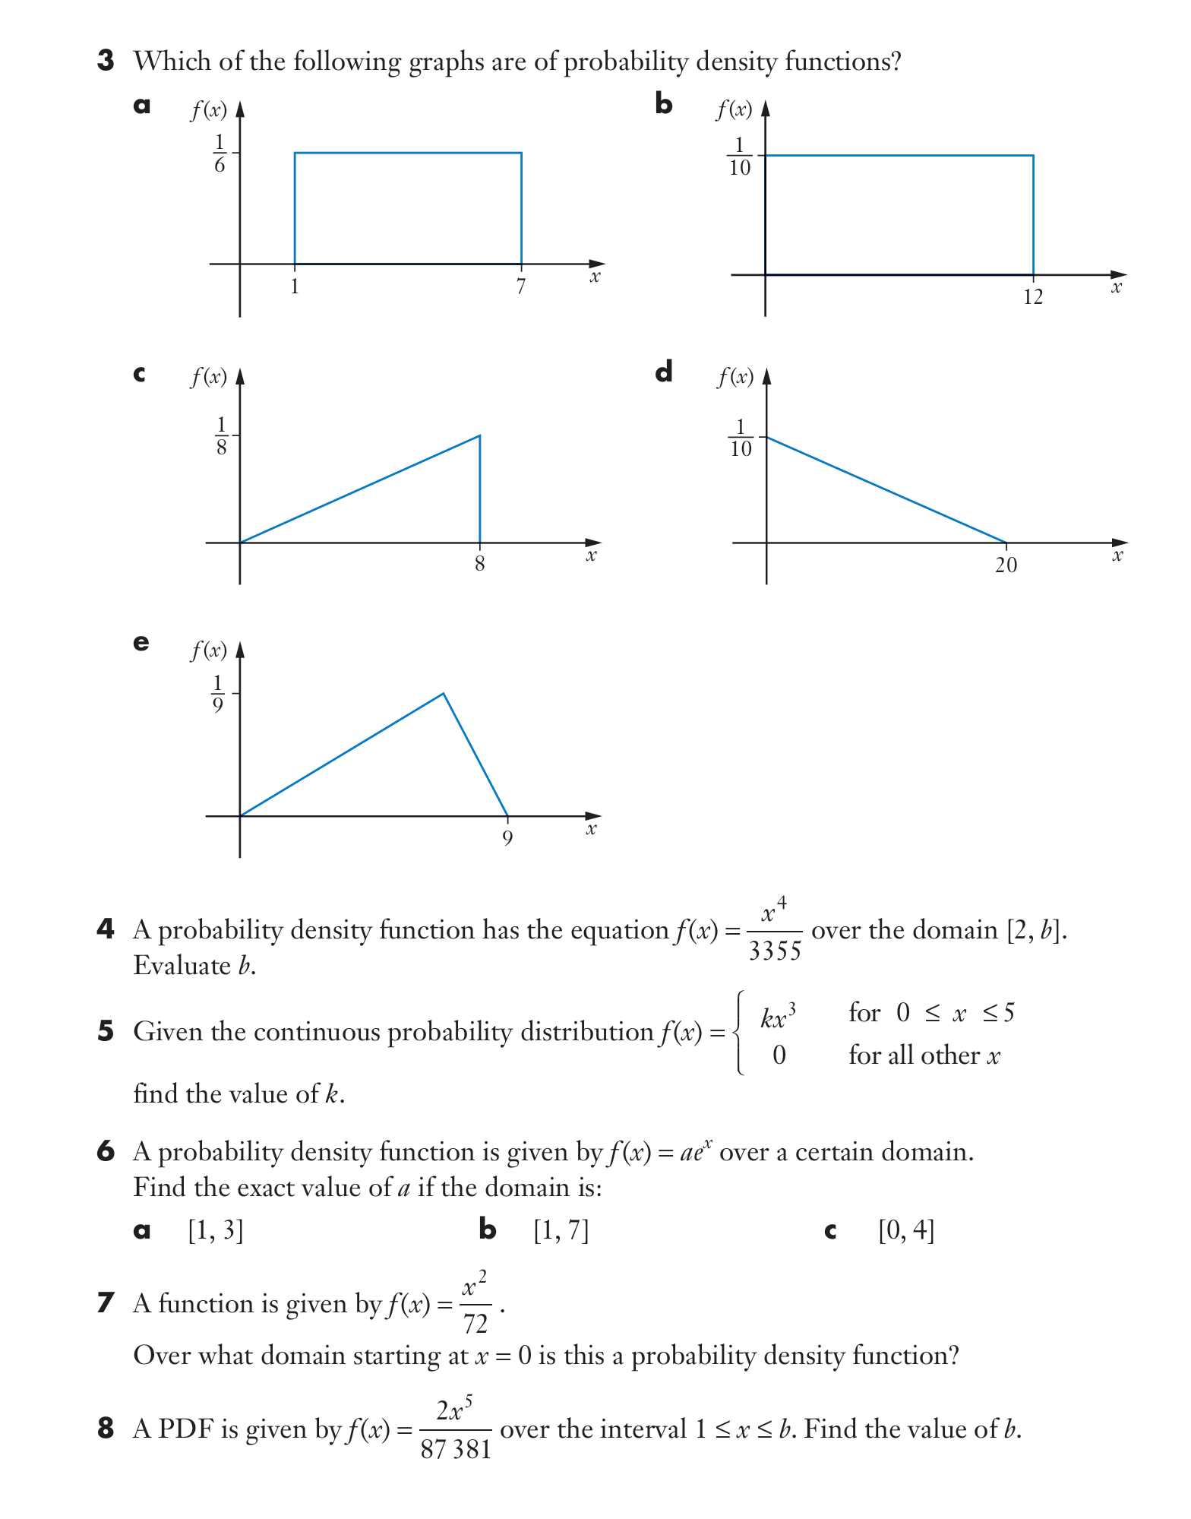  $$Area = \left(\frac{1}{6}\right)\left(6\right)= 1, f\left(x\right)≥ 0$$  Valid PDF. | $$Area = \left(\frac{1}{10}\right)\left(12\right)=\frac{12}{10}≠ 1$$  Not a PDF.
$$Area = \left(\frac{1}{2}\right)\left(20\right)\left(\frac{1}{10}\right)= 1, f\left(x\right)≥ 0$$  Valid PDF. | $$Area = \left(\frac{1}{2}\right)\left(9\right)\left(\frac{1}{9}\right)=\frac{1}{2}≠1$$  Not a PDF..

- Find $c$, given $f(x)$ is a PDF on the given domain.
  - $y = cx⁴,$ domain $[0, 3]$

$$\int_{0}^{3}{c}x^{4} dx=\frac{243c}{5}=1$$
$$c=\frac{5}{243}$$
  - $y = c$, domain $[0, 6]$

$$6c=1$$
$$c=\frac{1}{6}$$
  - $y = c$, domain $[-5, 5]$
$$10c=1$$
$$c=\frac{1}{10}$$
- Find $c$, given $f(x)$ is a PDF on the given domain.
  - $f(x) = \frac{8}{3}\left(1 - x\right),$domain $[0, c]$

$$\frac{8}{3}\int_{0}^{c}{(}1-x) dx=\frac{8}{3}\left(c-\frac{c^{2}}{2}\right)=1$$
$$4c^{2}-8c+3=0$$
$$\left(2c-1\right)\left(2c-3\right)=0. c=\frac{1}{2}or c=\frac{3}{2}$$
For $f(x)≥0$, need $1-x≥0$ throughout, so $c≤1$.
$$c=\frac{1}{2}$$

Development
- A function is given by $f\left(x\right)=$ $\frac{x^{2}}{72}$. Over what domain starting at $x = 0$ is this a PDF?

$$\int_{0}^{b}{\left(\frac{x^{2}}{72}\right)}dx = {\left[\frac{x^{3}}{216}\right]}_{0}^{b}=\frac{b^{3}}{216}= 1$$
$$b^{3}= 216, b = 6. Domain \left[0, 6\right]$$
- A PDF is given by $f\left(x\right)=$ $\frac{2x^{5}}{87381}$ over the interval $1 ≤ x ≤ b$. Find the value of $b$.

$$\int_{1}^{b}{\left(\frac{2x^{5}}{87381}\right)}dx = \left(\frac{2}{87381}\right){\left[\frac{x^{6}}{6}\right]}_{1}^{b}=\frac{b^{6}- 1}{262143}= 1$$
$$b^{6}= 262144 = 8^{6}, b = 8$$
- A PDF is given by $f(x) = ae^{x}$ over a certain domain. Find the exact value of $a$ if the domain is:
  - $[1, 7]$
  - $[0, 4]$

$$a) a\left(e^{7}- e\right)= 1$$
$$a =\frac{1}{e\left(e^{6}- 1\right)}$$

$$b) a\left(e^{4}- 1\right)= 1$$
$$a =\frac{1}{e^{4}- 1}$$
- Let $f(x)=$ $\frac{3}{4}$ $\left(x^{2}- 4x + 3\right)$ be defined on [0, 4].
  - Show that $\int_{0}^{4}{f\left(x\right)}dx = 1$.

$$\int_{0}^{4}{\frac{3}{4}}\left(x^{2}-4x+3\right) dx=\frac{3}{4}{\left[\frac{x^{3}}{3}-2x^{2}+3x\right]}_{0}^{4}$$
$$=\frac{3}{4}\left(\frac{64}{3}-32+12\right)$$
$$=\frac{3}{4}\left(\frac{4}{3}\right)=1$$
  - Show that $f(x)$ is not a valid PDF.

$f(x)=\frac{3}{4}(x-1)(x-3)$.
For $1<x<3$, $(x-1)>0$ and $(x-3)<0$, so $f(x)<0$.
Not a valid PDF as $f\left(x\right)$ is not always positive.

Calculating Probabilities using Integration

- Review
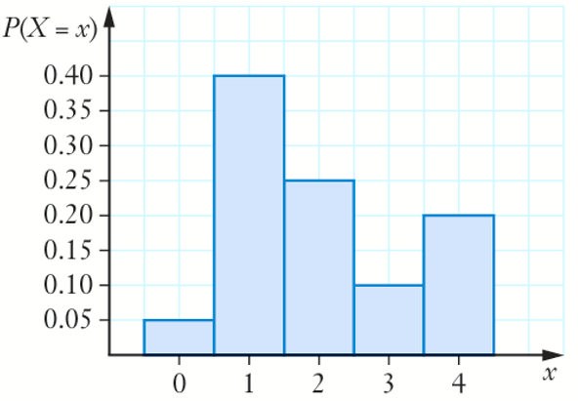
- Estimate probability in an interval using the relative frequency of classes

- Find $P\left(X=1\right)$ | - Find $P\left(X≤1\right)$ | - $P\left(X≥2\right)$
- Work with area of a rectangle
The area of these rectangles is 1. Find the missing length.
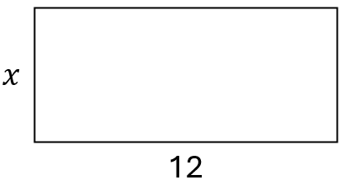 | 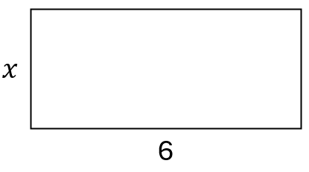
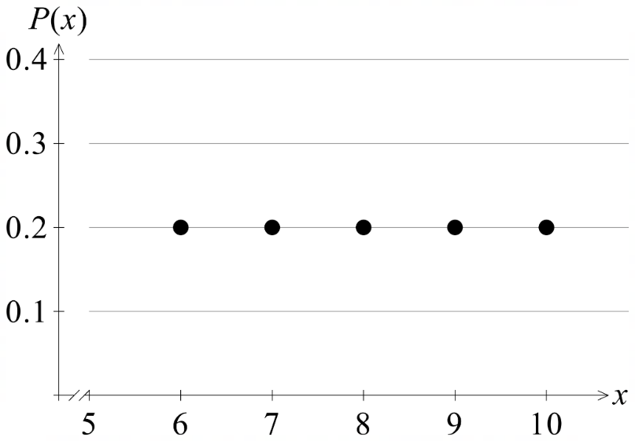
- Recall uniform distribution properties.
Consider the uniform distribution below. What is meant by a uniform distribution?
A probability distribution is uniform if the probability of each outcome is …………………

- Recall PDF properties
The area under a PDF must sum to …………

- The Probability is the Definite Integral
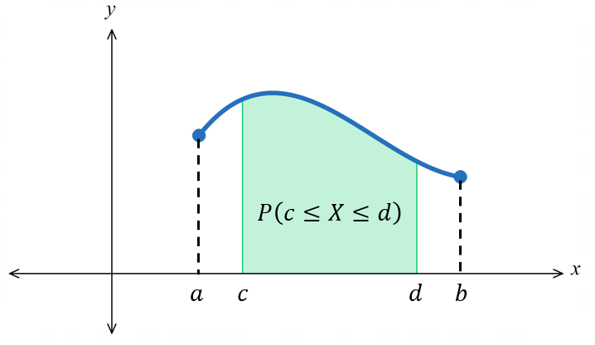
For a probability density function (PDF) $f\left(x\right)$ defined on $\left[a,b\right],$ the probability that $X$ falls between $c$ and $d$ is:

$$P\left(c≤X≤d\right)=\int_{c}^{d}{f\left(x\right)} dx, a≤c≤d≤b$$

If the requested interval extends beyond the domain, the limits of integration are restricted to the domain boundary. For a PDF defined on [1, 4]:
$P(X≤3)$ integrates from 1 to 3, not from $-∞$ or 0.

- Identify integral from probability notation
Consider a PDF $f\left(x\right)$ defined for the domain $\left[1, 4\right]$. Write the integral for:
- $P\left(2≤X≤3\right)$  $$\int_{2}^{3}{f\left(x\right)}dx$$ | - $P\left(0≤X≤3\right)$  $$\int_{1}^{3}{f\left(x\right)}dx$$ | - $P\left(2 ≤ X ≤ 5\right)$
- $P(X ≤ 3)$ | - $P(X ≥ 2)$ | - $P(-1 ≤ X ≤ 6)$
- $P(1.5 ≤ X ≤ 4)$ | - $P(X ≤ 5)$ | - $P(X ≥ 0)$

- Example Calculate probability of a PDF by integration
The continuous random variable $X$ has PDF
$$f\left(x\right)=\frac{x^{2}}{21} on \left[1, 4\right]$$
Find $P\left(2≤X≤3\right)$  $$\int_{2}^{3}{\frac{x^{2}}{21}}dx$$  $$={\left[\frac{x^{3}}{63}\right]}_{2}^{3}$$  $$=\frac{27}{63}-\frac{8}{63}$$  $$=\frac{19}{63}$$ | Find $P\left(X≥3\right)$  $$\int_{3}^{4}{\frac{x^{2}}{21}}dx$$  $$={\left[\frac{x^{3}}{63}\right]}_{3}^{4}$$  $$=\frac{64}{63}-\frac{27}{63}$$  $$=\frac{37}{63}$$

- Guided Practice
A continuous random variable is given by $f\left(x\right)=$ $\frac{3x^{2}}{117}$on $\left[2, 5\right]$. Find:
- $P\left(3≤X≤4\right)$  $$\frac{37}{117}$$ | - $P\left(X≤4\right)$  $$\frac{56}{117}$$
For $f\left(x\right)=$ $\frac{x^{2}}{21}$, find the value of $c$ such that $P\left(1≤X≤c\right)=$ $\frac{1}{2}$.

$$\sqrt[3]{\frac{65}{2}}$$

- Key Ideas
- For a continuous PDF, the integral $\int_{a}^{b}{f\left(x\right)}dx$ finds $P($ ……………… )
- If a requested interval extends beyond the domain, the integration limits are ……………………… to the domain boundary.

- Investigation Uniform probability distribution functions
Consider a uniform continuous probability distribution in the domain $\left[5, 15\right]$.
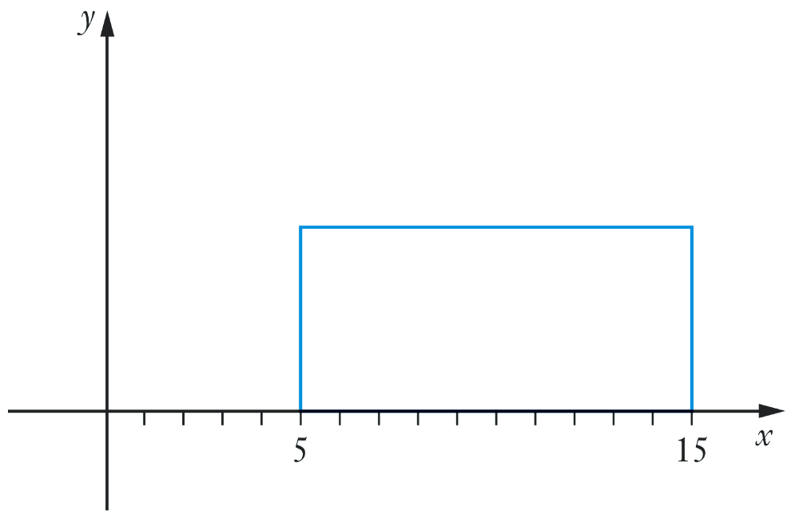
A uniform distribution has equal probabilities throughout its domain, this means $f\left(x\right)$ is ………………

The area under the graph is therefore the shape of a ……………………

The area of the rectangle is …………
The width of the rectangle is …………
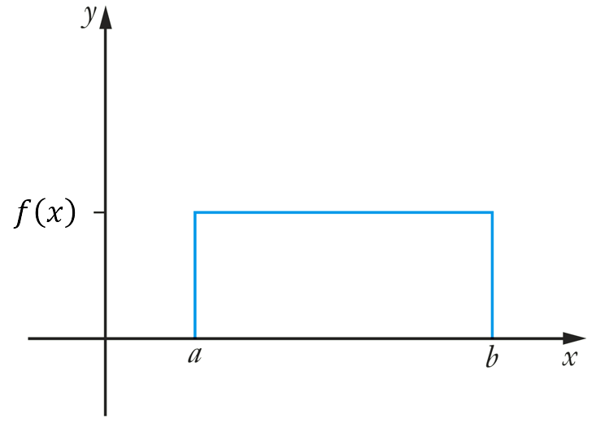
Therefore, the height of the rectangle is …………
So, $f\left(x\right)=$ …………

Generalising: For a uniform PDF defined for $\left[a,b\right]$,
The area of the rectangle is …………
The width of the rectangle is …………
So $f\left(x\right)=$ …………

- Uniform Distributions
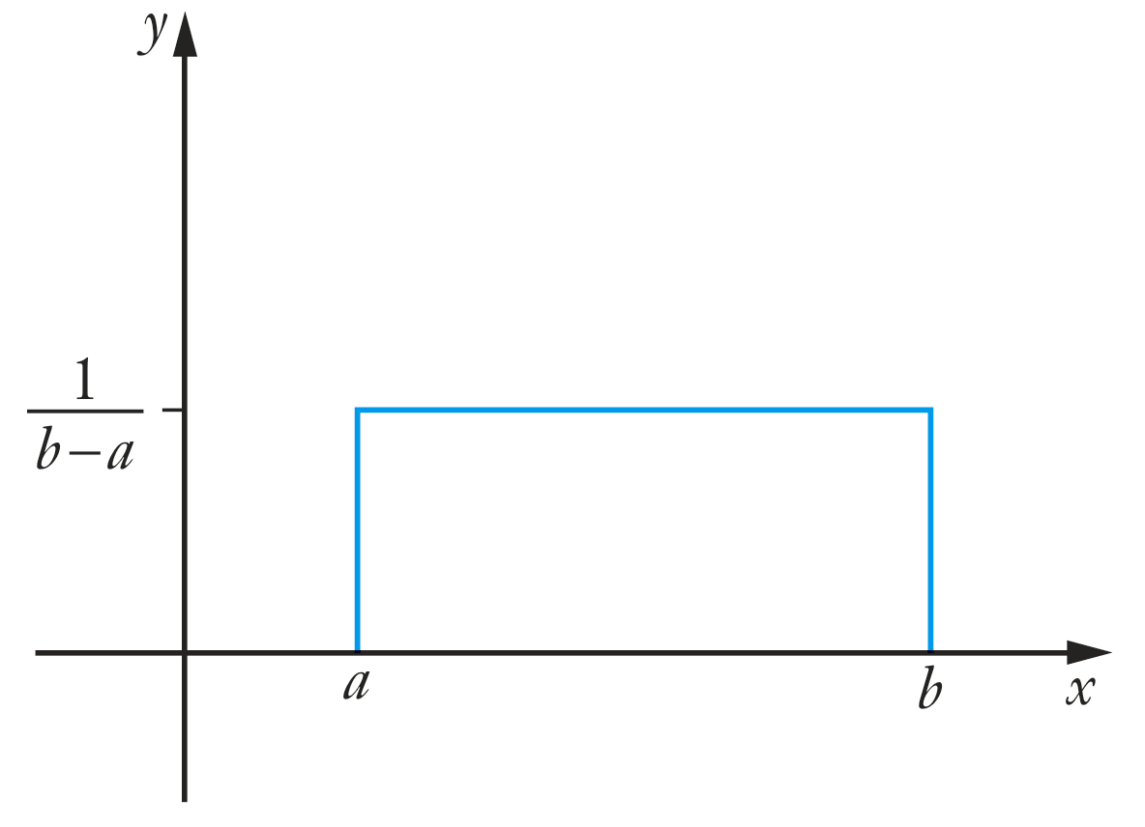
For a uniformly distributed PDF on $\left[a,b\right]$,
The PDF is
$$f\left(x\right)=\left\{\begin{aligned}\frac{1}{b-a} for a≤x≤b \\ 0 otherwise \end{aligned}\right.$$

- Example Calculate probability for a uniform PDF
The continuous random variable $X$ is uniformly distributed on $\left[2, 8\right]$.
Find the PDF $f\left(x\right)$.  $$f\left(x\right)=\frac{1}{8-2}=\frac{1}{6}$$ | Find $P\left(X≤5\right)$.  $$\int_{2}^{5}{\frac{1}{6}}dx={\left[\frac{x}{6}\right]}_{2}^{5}=\frac{5}{6}-\frac{2}{6} \\ =\frac{1}{2}$$

- Guided Practice
$X$ is a continuous random variable defined on $\left[7, 17\right].$
- Find the PDF $f\left(x\right)$  $$f\left(x\right)=\frac{1}{10}$$ | - Find $P\left(X>10\right)$  $$\frac{7}{10}$$

- Key Ideas
- A uniform distribution function defined for $\left[a,b\right]$ is the c………………… function:
$f\left(x\right)=$ ………………

Foundation
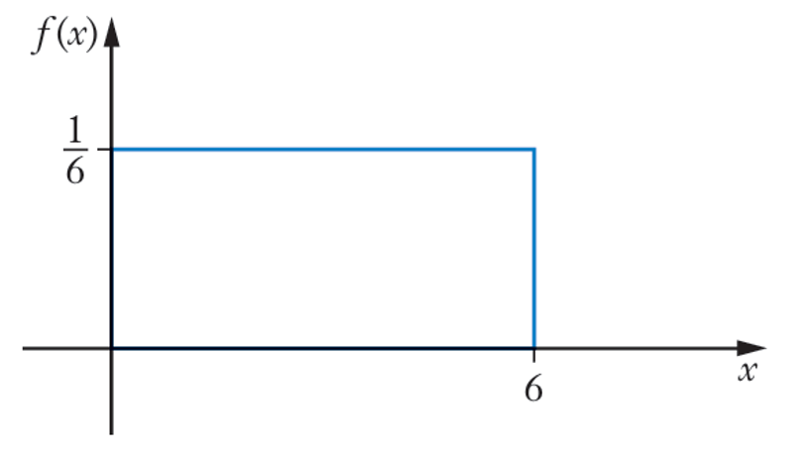
- For the continuous probability distribution graphed, find:
- $P(X ≤ 3)$  $$P\left(X ≤ 3\right)=\frac{1}{2}$$ | - $P(1 ≤ X ≤ 2)$  $$P\left(1 ≤ X ≤ 2\right)=\frac{1}{6}$$
- $P(1 ≤ X ≤ 4)$  $$P\left(1 ≤ X ≤ 4\right)=\frac{1}{2}$$ | - $P(X < 4)$  $$P\left(X < 4\right)=\frac{2}{3}$$
- $P\left(X ≥ 4\right)$  $$P\left(X ≥ 4\right)=\frac{1}{3}$$ | Probability is the area under the curve,  so, for a uniform distribution: $\frac{1}{6}$ $×width$

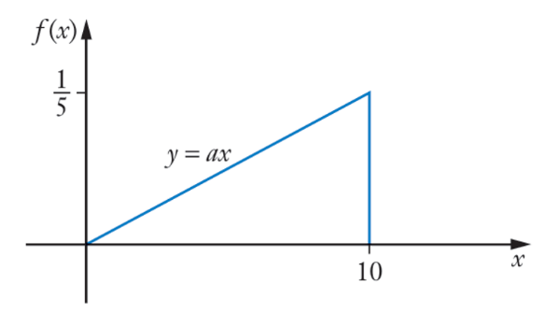
- A PDF is shown with $f(x) = ax$.
  - Find the equation of the linear function $y = ax$.

$$\int_{0}^{10}{\left(ax\right)}dx = 50a = 1$$
$$a =\frac{1}{50}$$
$$y =\frac{x}{50}$$
  - Find:
- $P(X < 9)$  $${\left[\frac{x^{2}}{100}\right]}_{0}^{9}=\frac{81}{100}$$ | - $P(X ≤ 3)$  $${\left[\frac{x^{2}}{100}\right]}_{0}^{3}=\frac{9}{100}$$ | - $P(4 ≤ X ≤ 7)$  $${\left[\frac{x^{2}}{100}\right]}_{4}^{7}=\frac{33}{100}$$
- $P(2 < X < 6)$  $${\left[\frac{x^{2}}{100}\right]}_{2}^{6}=\frac{8}{25}$$ | - $P\left(X > 5\right)$  $${\left[\frac{x^{2}}{100}\right]}_{5}^{10}=\frac{3}{4}$$

Development

  - Show that the uniform distribution $f\left(x\right)=$ $\frac{1}{b - a}$ for $a ≤ x ≤ b$, 0 for all other $x$, is a PDF.

$$Area = \left(b - a\right)×\frac{1}{b - a}= 1$$
$$f\left(x\right)≥ 0 on \left[a, b\right].$$
Therefore, it is a PDF.
  - If $a = 3$ and $b = 7$, find:
    - $P(X ≤ 6)$
    - $P(X ≥ 5)$
    - $P(5 ≤ X ≤ 6)$
$$b. With a = 3, b = 7, f\left(x\right)=\frac{1}{4}on \left[3, 7\right]$$
$$i. P\left(X ≤ 6\right)= \left(\frac{1}{4}\right)\left(3\right)=\frac{3}{4}$$
$$ii. P\left(X ≥ 5\right)= \left(\frac{1}{4}\right)\left(2\right)=\frac{1}{2}$$
$$iii. P\left(5 ≤ X ≤ 6\right)= \left(\frac{1}{4}\right)\left(1\right)=\frac{1}{4}$$
- The continuous PDF is defined by $f(x) = ax²$ in the domain [0, 5].
  - Evaluate $a$.
$$\int_{0}^{5}{\left({ax}^{2}\right)}dx =\frac{125a}{3}= 1$$
$$a =\frac{3}{125}$$
  - Find:
- $P(X ≤ 3)$  $${\left[\frac{x^{3}}{125}\right]}_{0}^{3}=\frac{27}{125}$$ | - $P(1 < X < 4)$  $${\left[\frac{x^{3}}{125}\right]}_{1}^{4}=\frac{63}{125}$$ | - $P(X > 2)$  $${\left[\frac{x^{3}}{125}\right]}_{2}^{5}=\frac{117}{125}$$

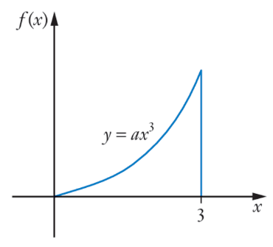
- The continuous random variable $X$ has PDF $f(x) = ax³$ on [0, 3].
  - Evaluate $a$.

$$\int_{0}^{3}{\left({ax}^{3}\right)}dx =\frac{81a}{4}= 1$$
$$a =\frac{4}{81}$$

  - Find:
- $P(1 ≤ X ≤ 3)$  $${\left[\frac{x^{4}}{81}\right]}_{1}^{3}=\frac{80}{81}$$ | - $P(X < 2)$  $${\left[\frac{x^{4}}{81}\right]}_{0}^{2}=\frac{16}{81}$$
- A continuous probability function is given by $f(x) = keˣ$, defined on [1, 6].
  - Find the exact value of $k$.

$$\int_{1}^{6}{\left(ke^{x}\right)}dx = k\left(e^{6}- e\right)= 1$$
$$k =\frac{1}{e\left(e^{5}- 1\right)}$$
  - Find each exact probability:
- $P(2 ≤ X ≤ 5)$  $$P\left(2 ≤ X ≤ 5\right)= k\left(e^{5}- e^{2}\right)$$  $$=\frac{e\left(e^{3}- 1\right)}{e^{5}- 1}$$ | - $P(X < 4)$  $$P\left(X < 4\right)= k\left(e^{4}- e\right)$$  $$=\frac{e^{3}- 1}{e^{5}- 1}$$ | - $P(X ≥ 3)$  $$P\left(X ≥ 3\right)= k\left(e^{6}- e^{3}\right)$$  $$=\frac{e^{2}\left(e^{3}- 1\right)}{e^{5}- 1}$$

  - Show that $y = sin x$ is a PDF in the domain $\left[0,\frac{π}{2}\right]$.

$$\int_{0}^{\frac{π}{2}}{sin}x dx = {\left[-cos x\right]}_{0}^{\frac{π}{2}}= -cos\left(\frac{π}{2}\right)+ cos\left(0\right)= 0 + 1 = 1.$$
$sin x ≥ 0 on \left[0,\frac{π}{2}\right]$
  - Find each exact probability:
- $P\left(X ≤\frac{π}{3}\right)$  $$P\left(X ≤\frac{π}{3}\right)= {\left[-cos x\right]}_{0}^{\frac{π}{3}}$$  $$= -\frac{1}{2}+ 1 =\frac{1}{2}$$ | - $P\left(0 < X <\frac{π}{4}\right)$  $$P\left(0 < X <\frac{π}{4}\right)= {\left[-cos x\right]}_{0}^{\frac{π}{4}}$$  $$= 1 -\frac{1}{\sqrt{2}}=\frac{\sqrt{2}- 1}{\sqrt{2}}$$ | - $P\left(X >\frac{π}{6}\right)$  $$P$$  $$\left(X >\frac{π}{6}\right)= {\left[-cos x\right]}_{\frac{π}{6}}^{\frac{π}{2}}$$  $$= 0 +\frac{\sqrt{3}}{2}=\frac{\sqrt{3}}{2}$$

Mode of a Continuous Distribution

- Review
- Identify mode from a histogram
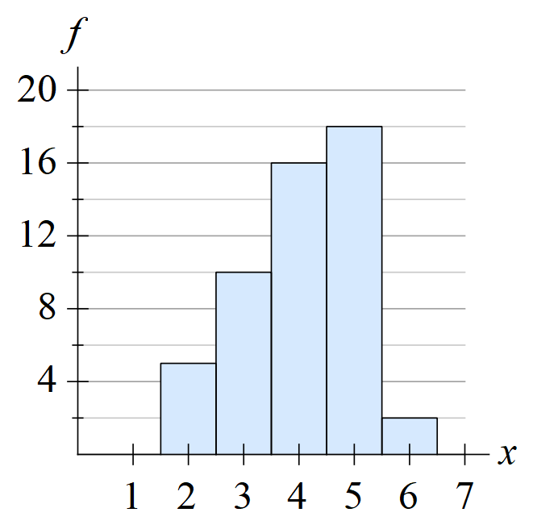 | 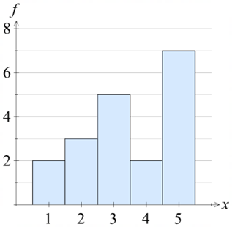 | 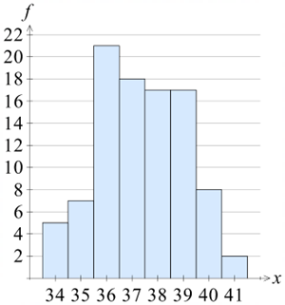
- Find global maxima
Find global minima and maxima in the domain $\left[0.5, 5\right]$ for $f\left(x\right)=x^{3}-6x^{2}+9x-4$.
Remember to confirm the nature of the point and check the endpoints of the domain.

global max at $\left(5,16\right)$
global min at $\left(3,-4\right)$

- Mode of a Continuous Distribution
The mode is the value of $x$ at which the PDF reaches its maximum.
To find the mode, we find the PDF’s maximum turning point.
- Differentiate $f\left(x\right)$
- Solve $f^{'}\left(x\right)=0$
- Check $x$ is in the domain of $f\left(x\right)$
- Confirm it is the global maximum using the second derivative or a gradient table, and by checking the function value at the boundaries.
- For a function that is always increasing $f^{'}\left(x\right)>0$, the mode is the end of its domain.
- For a function that is always decreasing $f^{'}\left(x\right)<0$, the mode is the start of its domain.

- Example Find the mode of a continuous probability function
A continuous random variable $X$ has PDF defined on $\left[0,4\right]$: $f\left(x\right)=$ $\frac{3x\left(4-x\right)}{32}$
Find its mode.
1. Differentiate  $$f\left(x\right)=\frac{3}{32}\left(4x-x^{2}\right) \\ f^{'}\left(x\right)=\frac{3}{32}\left(4-2x\right) \\ f^{'}\left(x\right)=\frac{3}{16}\left(2-x\right)$$  2. Solve $f^{'}\left(x\right)=0$  $$0=\frac{3}{16}\left(2-x\right)$$  $$x=2$$ | 3. Check domain  $x=2$ is in $\left[0, 4\right]$ ✓  4. Check maximum  $$f^{''}\left(x\right)=-\frac{3}{16}<0∴max$$  $$f\left(0\right)=0, f\left(2\right)=\frac{3}{8}, f\left(4\right)=0$$  $∴x=2$ is the mode.

- Guided Practice
- Find the mode of $f\left(x\right)=$ $\frac{x\left(6-x\right)}{18}$ on $\left[0, 6\right]$.  $$x=3$$ | - Find the mode of $f\left(x\right)=$ $\frac{3x^{2}}{26}$ on $\left[1,3\right]$.  $$x=3$$

Foundation
- Find the mode of each continuous probability distribution.
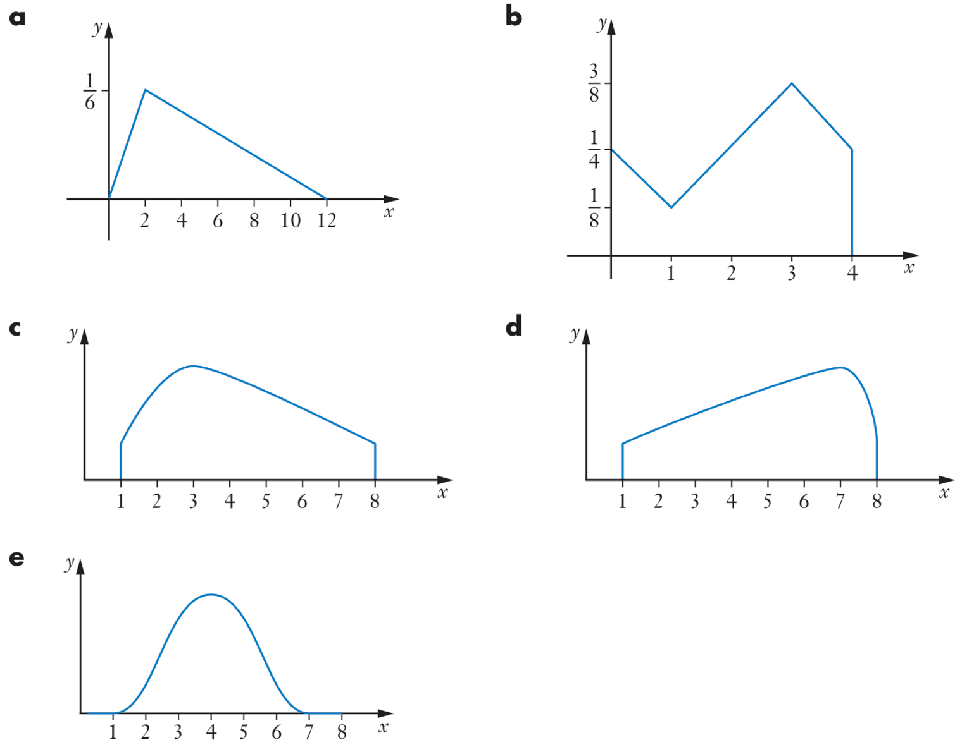  $$2$$ | 4
3 | 7

- Find the mode of each continuous probability distribution.
  - $f(x) = -$ $\frac{3\left(x^{2}- 8x - 9\right)}{434}$ defined in the domain [0, 7]
This is a concave down parabola. The turning point must be maximum.
$$f^{'}\left(x\right)= -\frac{3\left(2x - 8\right)}{434}= 0$$
$x = 4$
Mode = 4
  - $f(x) = -$ $\frac{3\left(x^{2}- 16x + 15\right)}{1100}$ defined in the domain [1, 11]
This is a concave down parabola. The turning point must be maximum.
$$f^{'}\left(x\right)= -\frac{3\left(2x - 16\right)}{1100}= 0$$
$$x = 8$$
Mode = 8.
  - $f\left(x\right)=$ $\frac{4e^{4x}}{e^{8\left(e^{16}- 1\right)}}$ defined in the interval $2 ≤ x ≤ 6$

$$f^{'}\left(x\right)=\frac{16e^{4x}}{e^{8\left(e^{16}- 1\right)}}> 0 always increasing on \left[2, 6\right].$$
The maximum is at the end of the domain.
Mode = 6.

- Find the mode of $f\left(x\right)=$ $\frac{2\left(2x^{3}- 33x^{2}+ 168x + 3\right)}{2105}$ defined in the interval $0 ≤ x ≤ 5$

$$f^{'}\left(x\right)=\frac{2\left(6x^{2}- 66x + 168\right)}{2105}= 0$$
$x^{2}- 11x + 28 = 0$
$\left(x - 4\right)\left(x - 7\right)= 0.$
$x = 4 i$s in [0, 5].
Check second derivative:
$$f^{''}\left(x\right)=2x-11$$
$$f^{''}\left(4\right)=-3<0∴max$$
$$Check f\left(0\right)=\frac{6}{2105}, f\left(4\right)=\frac{110}{421}≈0.26, f\left(5\right)=\frac{536}{2105}≈0.25:$$
Mode = 4.

- Determine whether each function is a PDF. If it is, find its mode.
  - $f\left(x\right)= 3x^{2}, where 0 ≤ x ≤ 1$
$$\int_{0}^{1}{3}x^{2} dx=1,$$
$$f\left(x\right)≥0 for all x$$
$f^{'}(x)=6x>0$, increasing. Mode = $1$.
  - $f\left(x\right)=\frac{1}{4}x, where 1 ≤ x ≤ 5$

$$\int_{1}^{5}{\frac{1}{4}}x dx=\frac{24}{8}=3≠1$$
Not a PDF.
  - $f\left(x\right)=$ $\frac{4 - 2x}{3}$ $, where 0 ≤ x ≤ 3$

$$\int_{0}^{3}{\frac{4-2x}{3}} dx={\left[\frac{4x}{3}-\frac{x^{2}}{3}\right]}_{0}^{3}=4-3=1$$
but $f(x)<0$ for $x>2$. Not a PDF.
  - $f\left(x\right)= \left(n + 1\right)xⁿ, where 0 ≤ x ≤ 1, n ≥ 0$

$$\int_{0}^{1}{\left( n+1\right)x^{n}} dx={\left[x^{n+1}\right]}_{0}^{1}=1$$
$$f\left(x\right)≥0 for all positive x$$
$f^{'}(x)=n(n+1)x^{n-1}≥0$, increasing.
Mode = $1$.
  - $f\left(x\right)=\frac{1}{2}sin x, where 0 ≤ x ≤ π$
$$\int_{0}^{π}{\frac{1}{2}}sinx dx=\frac{1}{2}{\left[-cosx\right]}_{0}^{π}=1$$
$$f\left(x\right)≥0$$
Mode at max value of sine: $sinx=1$: $x=\frac{π}{2}$.

Cumulative Distribution Functions

- Review
- Integrate to a variable upper limit
$$\int_{1}^{x}{t^{2}}dt$$ | $$\int_{0}^{x}{3t}dt$$ | $$\int_{2}^{x}{t^{3}}dt$$
- Find cumulative frequency for a frequency table
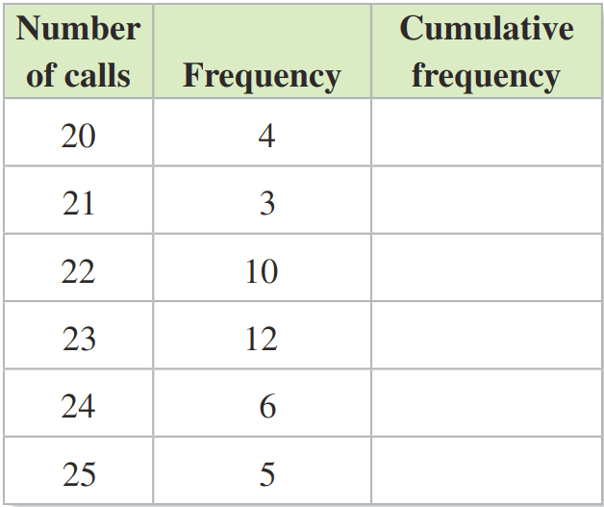
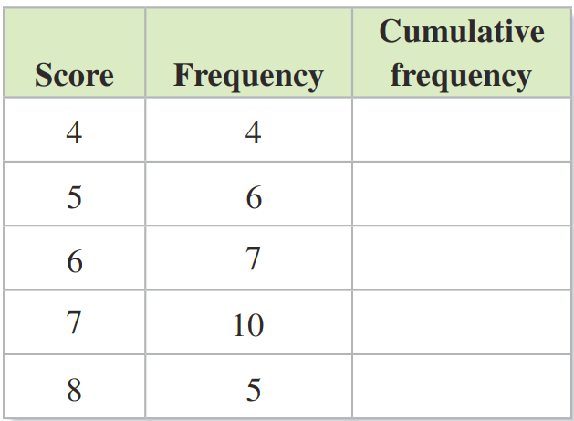

- Construct cumulative frequency histogram from regular histogram
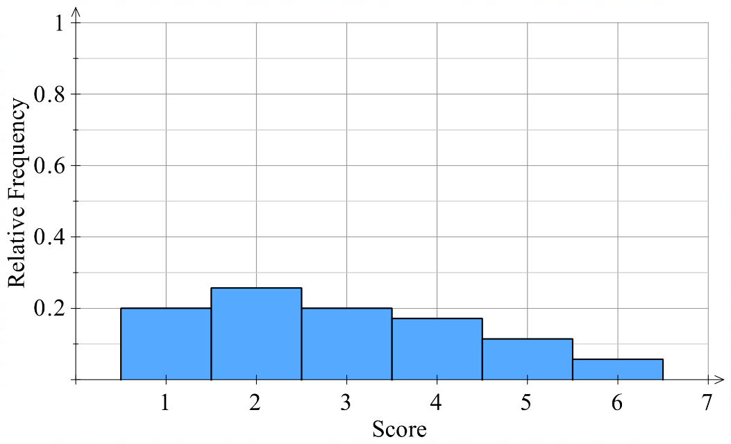
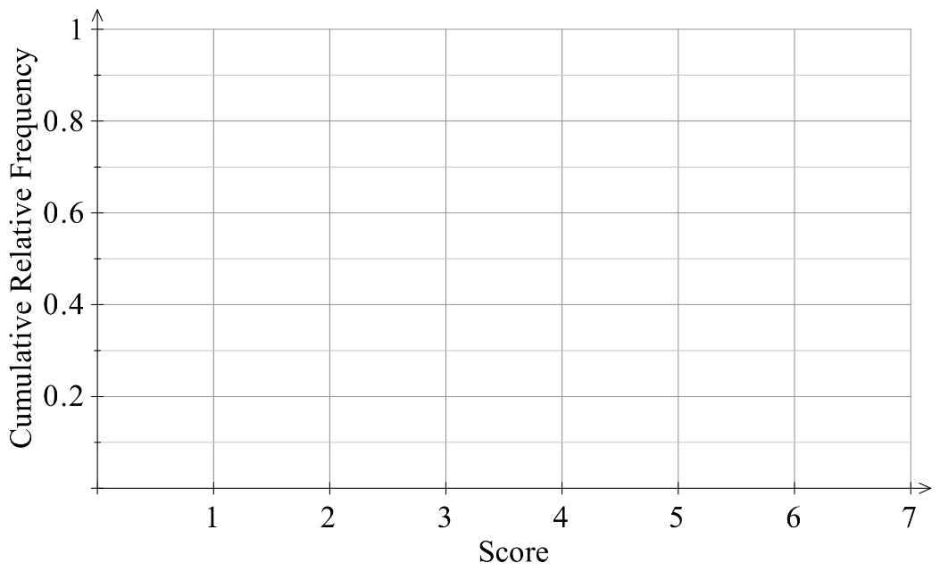

- Find the median and IQR from a cumulative frequency polygon
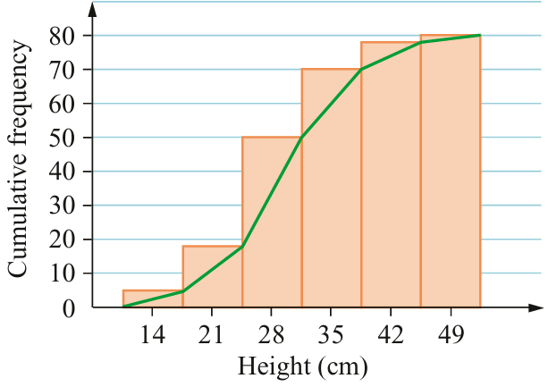 | 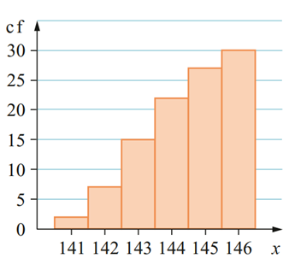

- Cumulative Distribution Function
For a continuous probability distribution $f\left(t\right)$ defined on $\left[a,b\right]:$
The cumulative distribution function (CDF), $F\left(x\right)$, gives the probability that $X$ is less than or equal to $x$. It is the area under the graph from $a$ to $x,$ so it is the integral from $a$ to $x$.
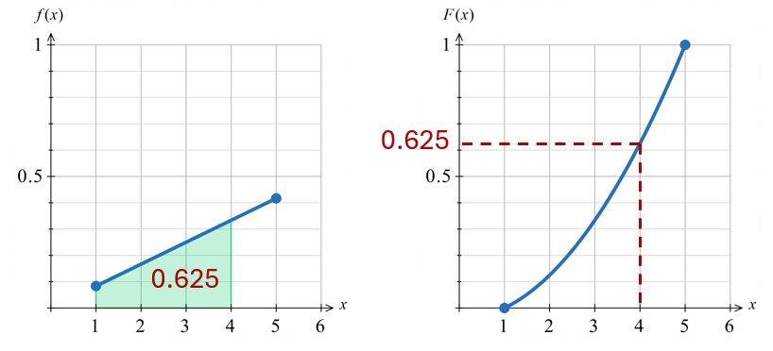

$$F\left(x\right)=P\left(X≤x\right)=\int_{a}^{x}{f(t)}dt$$

Properties:
- The PDF is the derivative of the CDF.

- A CDF is always monotonically increasing.
The cumulative probability cannot decrease.

- At the left boundary of the domain, $F\left(a\right)=0$.
- At the right boundary of the domain, $F\left(b\right)=1$.
- For any $x$ between $a$ and $b$, $0<F\left(x\right)<1$.

- Properties of the CDF
- The function value of the CDF gives the cumulative probability.
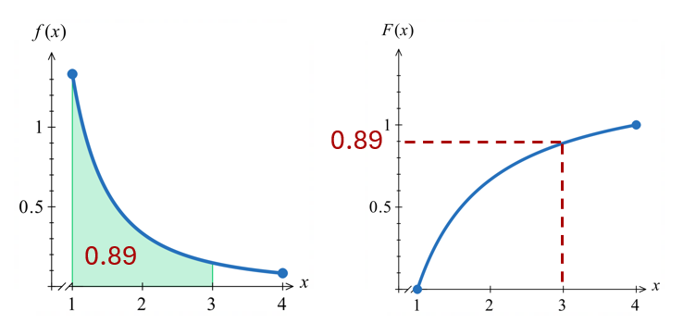

$$F\left(a\right)=P\left(X≤a\right)$$

- To find the probability of an interval using the CDF,
subtract the CDF values at the two endpoints.
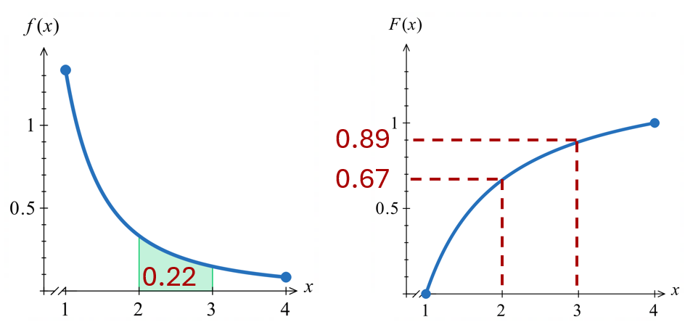

$$P\left(c≤X≤d\right)=F\left(d\right)-F\left(c\right)$$

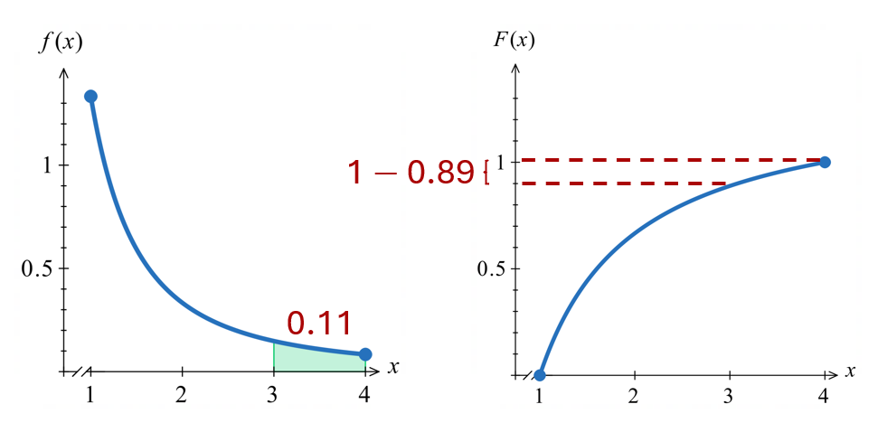
- To find the probability of $X$ greater than or equal to $a$, subtract the probability less than or equal to $a$ from 1.

$$P\left(X≥a\right)=1-P\left(X≤a\right)$$
$=1-F\left(a\right)$

- Example Find the cumulative distribution function
The continuous random variable has PDF $f\left(x\right)=$ $\frac{x^{2}}{21}$ defined on $\left[1, 4\right]$.
Find the CDF and use it to find $P\left(X≤3\right)$ and $P\left(2≤x≤3\right)$.
$$F\left(x\right)=\int_{1}^{x}{\frac{t^{2}}{21}}dt \\ =\frac{1}{21}{\left[\frac{t^{3}}{3}\right]}_{1}^{x} \\ =\frac{1}{21}\left(\frac{x^{3}}{3}-\frac{1}{3}\right) \\ =\frac{x^{3}-1}{63}$$ | 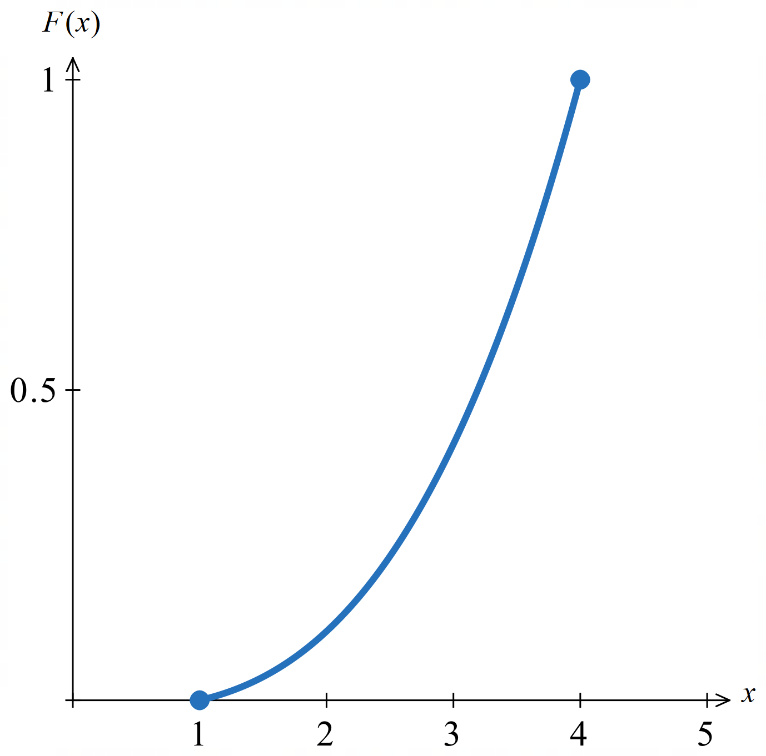
$$P\left(X≤3\right)=F\left(3\right)=\frac{26}{63}$$ | $$P\left(2≤X≤3\right)=F\left(3\right)-F\left(2\right)=\frac{26}{63}-\frac{7}{63}=\frac{19}{63}$$
- Guided Practice
A PDF is $f\left(x\right)=$ $\frac{3x^{2}}{335}$ on $\left[2,7\right].$
- Find the cumulative distribution function.  $$\frac{x^{3}-8}{335}$$ | The CDF has been sketched for you:  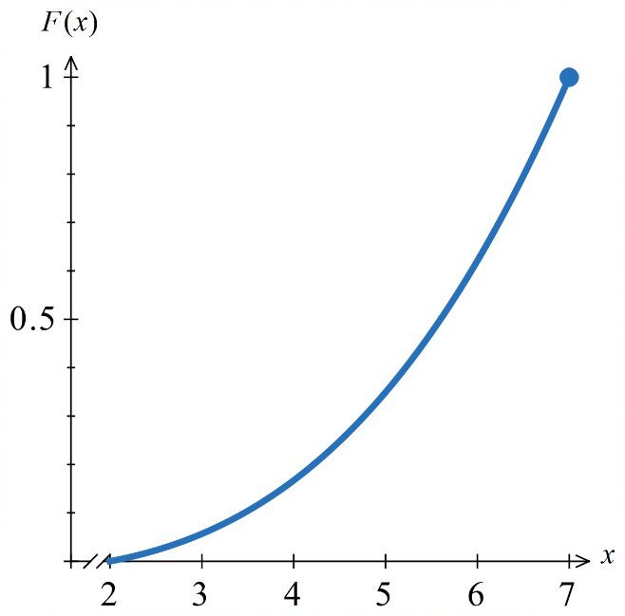
- Find $P\left(X≤4\right)$  $$\frac{56}{335}$$ | - $P\left(3.5≤X≤6.2\right)$  $$0.583$$
A PDF is $f\left(x\right)=$ $\frac{4}{3x^{2}}$ on $\left[1,4\right].$
- Find the cumulative distribution function.  $$\frac{4}{3}-\frac{4}{3x}$$ | The CDF has been sketched for you:  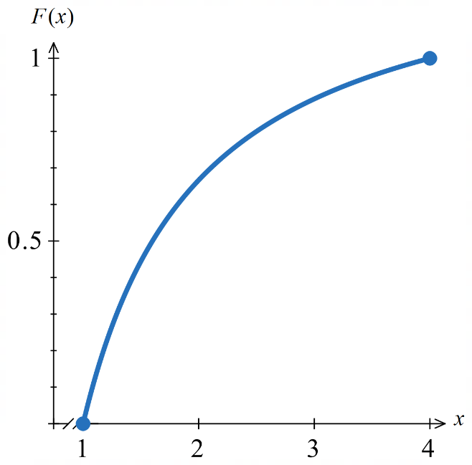
- Find $P\left(2≤X≤3\right)$  $$\frac{2}{9}$$ | - $P\left(X≥2\right)$  $$\frac{1}{3}$$

Foundation
- Find the cumulative distribution function for each continuous probability distribution.
  - $f\left(x\right)=$ $\frac{x^{2}}{9}$ defined in the domain [0, 3]

$$F\left(x\right)= \int_{0}^{x}{\left(\frac{t^{2}}{9}\right)}dt =\frac{x^{3}}{27}$$
  - $f\left(x\right)=$ $\frac{eˣ}{e^{4}- 1}$ in the interval $0 ≤ x ≤ 4$

$$F\left(x\right)= \int_{0}^{x}{\left(\frac{e^{t}}{e^{4}-1}\right)}dt =\frac{eˣ - 1}{e^{4}- 1}$$
  - $f\left(x\right)=$ $\frac{4{\left(x - 2\right)}^{3}}{625}$ in the domain [2, 7]

$$F\left(x\right)= \int_{2}^{x}{\left(\frac{4{\left(t-2\right)}^{3}}{625}\right)}dt =\frac{{\left(x - 2\right)}^{4}}{625}$$
  - $f\left(x\right)=$ $\frac{3x\left(8 - x\right)}{135}$ in the domain [2, 5]

$$F\left(x\right)= \int_{2}^{x}{\left(\frac{3t\left(8-t\right)}{135}\right)}dt = \left(\frac{3}{135}\right){\left[4t^{2}-\frac{t^{3}}{3}\right]}_{2}^{x}$$
$$=\frac{12x^{2}- x^{3}- 40}{135}$$

- For each PDF, find $F(x)$ and confirm $F(b) = 1$.
  - $f\left(x\right)=\frac{1}{32}x, where 0 ≤ x ≤ 8$
$$F\left(x\right)=\int_{0}^{x}{\frac{t}{32}} dt=\frac{x^{2}}{64}.$$
$$F\left(8\right)=\frac{64}{64}=1$$
  - $f\left(x\right)=\frac{3}{16}x^{2}, where -2 ≤ x ≤ 2$
$$F\left(x\right)=\int_{-2}^{x}{\frac{3t^{2}}{16}} dt={\left[\frac{t^{3}}{16}\right]}_{-2}^{x}=\frac{x^{3}+8}{16}.$$
$$F\left(2\right)=\frac{16}{16}=1$$
  - $f\left(x\right)=\frac{3}{2}\left(1 - x^{2}\right), where 0 ≤ x ≤ 1$
$$F\left(x\right)=\int_{0}^{x}{\frac{3}{2}}\left(1-t^{2}\right) dt=\frac{3x-x^{3}}{2}$$
$$F(1)=\frac{2}{2}=1$$
  - $f\left(x\right)=\frac{1}{e}\left(eˣ + 1\right), where 0 ≤ x ≤ 1$
$$F(x)=\frac{1}{e}\int_{0}^{x}{(}e^{t}+1) dt=\frac{1}{e}(e^{x}+x-1)$$
$$F(1)=\frac{1}{e}(e)=1$$

- The function $y=2x, 0 ≤ x ≤ 1,$ is a PDF.
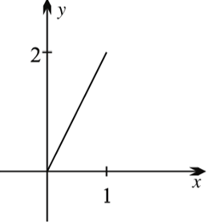
  - Sketch the graph and verify $f(x) ≥ 0$.

$f(x)=2x≥0$ for $x≥0$,
so $f\left(x\right)≥0$ in $\left[0,1\right]$

  - Show the area bounded by the function and the $x$-axis is 1; confirm by integration.
Triangle with base $1$ and height $2$: area = $\frac{1}{2}(1)(2)=1$
$$\int_{0}^{1}{2}x dx={\left[x^{2}\right]}_{0}^{1}=1$$
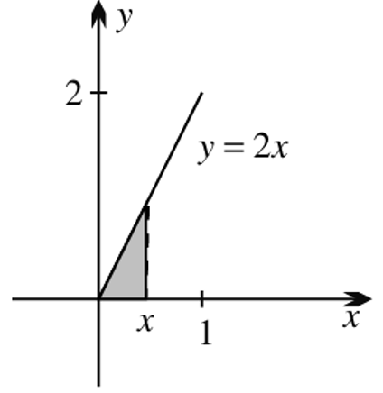
  - Use area formulae to show the CDF is $P(X ≤ x) = x².$

Area is half base times height
$$A=\frac{1}{2}x×2x=x^{2}$$
  - Confirm by calculating $\int_{0}^{x}{2t}dt.$

$${\left[t^{2}\right]}_{0}^{x}=x^{2}$$
  - Use the CDF to find Q₁, Q₂ and Q₃.
$$Q1: \frac{1}{2}$$
$$Q2: \frac{1}{\sqrt{2}}$$
$$Q3:\frac{\sqrt{3}}{2}$$

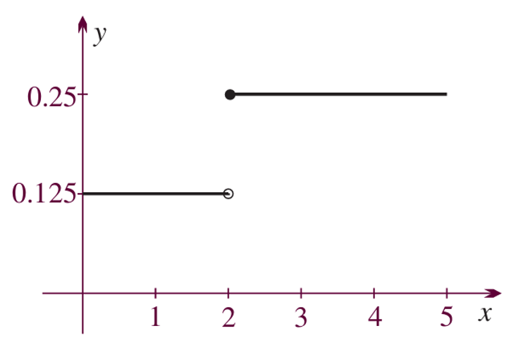
- A piecewise function is graphed: $f(x) = 0.125$ for $0 ≤ x < 2, f(x) = 0.25$ for $2 ≤ x ≤ 5$.
  - Verify it forms a valid PDF.

Area = $2(0.125)+3(0.25)=0.25+0.75=1$.
$f(x)≥0$. Valid PDF.
  - Complete the cumulative probability table $P\left(X ≤ x\right) for x = 0, 1, 2, 3, 4, 5$.
$$x$$ | 0 | 1 | 2 | 3 | 4 | 5
$$P\left(X≤x\right)$$
$$0,\frac{1}{8},\frac{1}{4},\frac{1}{2},\frac{3}{4}, 1$$
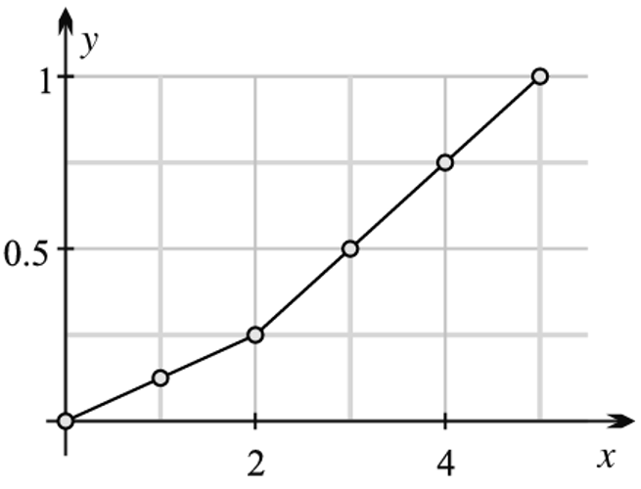
  - Plot and graph the CDF and write the CDF in piecewise notation.
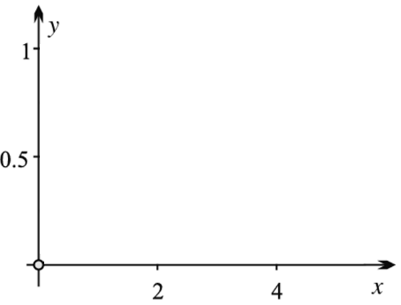

$$F(x)=\left\{\begin{matrix}\frac{1}{8}x, & \text{for }0≤x<2 \\ \frac{1}{4}x-\frac{1}{4}, & \text{for }2≤x≤5\end{matrix}\right.$$

- A PDF is defined by
$$f(x)=\left\{\begin{matrix}c, & \text{for }0≤x≤5 \\ 2c, & \text{for }5<x≤10\end{matrix}\right.$$
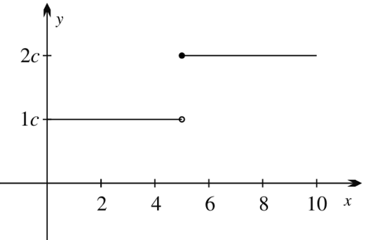
  - Sketch the PDF.

  - Find $c$.
Area = $5c+5(2c)=15c=1$
$$c=\frac{1}{15}$$
  - Find the CDF.
$$F(x)=\left\{\begin{matrix}cx=\frac{x}{15}, & \text{for }0≤x<5 \\ 2cx-5c=\frac{2x}{15}-\frac{1}{3}, & \text{for }5≤x≤10\end{matrix}\right.$$
  - Use the CDF to find $P(1 < X < 7).$
$$P\left(1<X<7\right)=F\left(7\right)-F\left(1\right)$$
$$=\left(\frac{14}{15}-\frac{1}{3}\right)-\frac{1}{15}$$
$$=\frac{8}{15}$$

Development
- A continuous probability distribution is defined by $f\left(x\right)=$ $\frac{2e^{2x}}{e^{10}- 1}$ in the domain [0, 5].
  - Find the CDF.

$$F\left(x\right)= \int_{0}^{x}{\left(\frac{2e^{2t}}{e^{10}-1}\right)}dt =\frac{e^{2x}- 1}{e^{10}- 1}$$
  - Calculate each probability correct to 2 significant figures.
- $P(X ≤ 2)$  $$P\left(X ≤ 2\right)=F\left(2\right)$$  $$=\frac{e^{4}- 1}{e^{10}- 1}≈ 0.0024$$ | - $P(X ≤ 4)$  $$P\left(X ≤ 4\right)$$  $$=\frac{e^{8}- 1}{e^{10}- 1}≈ 0.14$$ | - $P(X > 3)$  $$P\left(X > 3\right)$$  $$= 1 -\frac{e^{6}- 1}{e^{10}- 1}≈ 0.98$$
- $P(X ≥ 2.8)$  $$P\left(X ≥ 2.8\right)$$  $$= 1 - F\left(2.8\right)≈ 0.99$$ | - $P(2 ≤ X ≤ 4)$  $$P\left(2 ≤ X ≤ 4\right)$$  $$= F\left(4\right)- F\left(2\right)≈ 0.13$$

  - Find the exact value of $a$ if $f\left(x\right)=$ $\frac{a}{x}$ is a continuous PDF defined in the domain [1, 6].

$$\int_{1}^{6}{\frac{a}{x}}dx =a\left(\ln{6}-\ln{1}\right)= 1$$
$$a =\frac{1}{\ln{6}}.$$
  - Find the CDF.

$$F\left(x\right)= \int_{1}^{x}{\left(\frac{1}{t·\ln{6}}\right)}dt =\frac{ln x}{\ln{6}}$$
  - Find to 2 decimal places:
- $P(X ≤ 3)$  $$P\left(X ≤ 3\right)= \frac{\ln{3}}{\ln{6}} ≈ 0.61$$ | - $P(X ≤ 2)$  $$P\left(X ≤ 2\right)= \frac{\ln{2}}{\ln{6}} ≈ 0.39$$ | - $P(X > 5)$  $$P\left(X > 5\right)= 1 -\frac{\ln{5}}{\ln{6}} ≈ 0.10$$
- $P(X ≥ 4)$  $$P\left(X ≥ 4\right)= 1 - \frac{\ln{4}}{\ln{6}}≈ 0.23$$ | - $P(2 ≤ X ≤ 5)$  $$P\left(2 ≤ X ≤ 5\right)=\frac{\ln{5} -\ln{2}}{\ln{6}}$$  $$=\frac{ln\left(\frac{5}{2}\right)}{\ln{6}} ≈ 0.51$$

  - Show that $y = cos x$ is a PDF in the domain $\left[\frac{3π}{2}, 2π\right].$
$$\int_{\frac{3π}{2}}^{2π}{cos}x dx = {\left[sin x\right]}_{\frac{3π}{2}}^{2π}$$
$$= sin\left(2π\right)- sin\left(\frac{3π}{2}\right)$$
$$= 0 - \left(-1\right)= 1$$
$cos x ≥ 0$ on $\left[\frac{3π}{2}, 2π\right]$(cos positive in Q4)
Therefore, it is a PDF
  - Find the CDF.
$$F\left(x\right)= \int_{\frac{3π}{2}}^{x}{cos}t dt$$
$$= {\left[sin t\right]}_{\frac{3π}{2}}^{x}$$
$$= sin x + 1$$
  - Find each probability in exact form:
- $P\left(X ≤\frac{5π}{3}\right)$  $$P\left(X ≤\frac{5π}{3}\right)= sin\left(\frac{5π}{3}\right)+ 1$$  $$= -\frac{\sqrt{3}}{2}+ 1$$  $$=\frac{2 - \sqrt{3}}{2}$$ | - $P\left(X ≥\frac{7π}{4}\right)$  $$P\left(X ≥\frac{7π}{4}\right)= 1 - F\left(\frac{7π}{4}\right)= 1 - \left(sin\left(\frac{7π}{4}\right)+ 1\right)$$  $$= -sin\left(\frac{7π}{4}\right)$$  $$=\frac{1}{\sqrt{2}}$$ | - $P\left(\frac{5π}{3}≤ X ≤\frac{11π}{6}\right)$  $$P\left(\frac{5π}{3}≤ X ≤\frac{11π}{6}\right)= F\left(\frac{11π}{6}\right)- F\left(\frac{5π}{3}\right)$$  $$= sin\left(\frac{11π}{6}\right)- sin\left(\frac{5π}{3}\right)$$  $$= -\frac{1}{2}- \left(-\frac{\sqrt{3}}{2}\right)$$  $$=\frac{\sqrt{3}- 1}{2}$$

  - Find the CDF for $f\left(x\right)=$ $\frac{5x^{4}}{7776}$ for $1 ≤ x ≤ 6$.

$$F\left(x\right)= \int_{1}^{x}{\left(\frac{5t^{4}}{7776}\right)}dt =\frac{x^{5}- 1}{7776}$$
  - Find:
- $P(X ≤ 3)$  $$P\left(X ≤ 3\right)= F\left(3\right)=\frac{121}{3888}$$ | - $P(X ≤ 2)$  $$P\left(X ≤ 2\right)= F\left(2\right)=\frac{31}{7776}$$ | - $P(X < 5)$  $$P\left(X < 5\right)= F\left(5\right)=\frac{781}{1944}$$
- $P(X > 4)$  $$P\left(X > 4\right)= 1 - F\left(4\right)$$  $$= 1 -\frac{1023}{7776}=\frac{2251}{2592}$$ | - $P(2 ≤ X ≤ 4)$  $$P\left(2 ≤ X ≤ 4\right)= F\left(4\right)- F\left(2\right)=\frac{31}{243}$$
- A probability density function is defined piecewise by
$$f\left(x\right)=\left\{\begin{aligned}k\left(4+x\right) -4≤x≤0 \\ k(4-x) 0≤x≤4\end{aligned}\right.$$
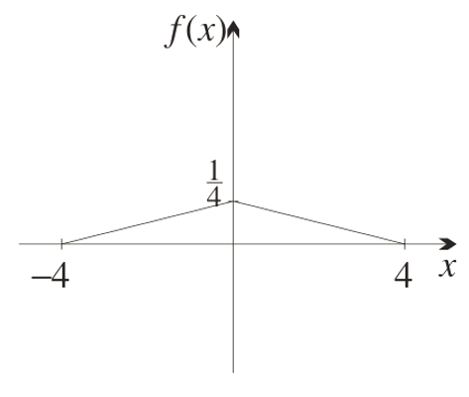
  - Find the value of the constant $k$. Hence write the equation of $f(x)$ and sketch it.

$$\int_{-4}^{4}{f\left(x\right)}dx = 1. Split region based on piecewise definition:$$
$$\int_{-4}^{0}{k\left(4 + x\right)}dx + \int_{0}^{4}{k\left(4 - x\right)}dx$$
$$= k{\left[4x + \left(\frac{1}{2}\right)x^{2}\right]}_{-4}^{0}+ k{\left[4x - \left(\frac{1}{2}\right)x^{2}\right]}_{0}^{4}$$
$$= k\left(\left(0 + 0\right)- \left(-16 + 8\right)\right)+ k\left(\left(16 - 8\right)- \left(0 - 0\right)\right)$$
$$= 8k + 8k = 16k = 1$$
$$k =\frac{1}{16}$$
$$f\left(x\right)=\left\{\begin{aligned}\frac{1}{16}\left(4+x\right) -4≤x≤0 \\ \frac{1}{16}(4-x) 0≤x≤4\end{aligned}\right.$$
  - What is the probability that $0 ≤ X ≤ 2$?

$$P\left(0 ≤ X ≤ 2\right)= \int_{0}^{2}{\left(\frac{1}{16}\right)\left(4 - x\right)}dx$$
$$= \left(\frac{1}{16}\right){\left[4x - \left(\frac{1}{2}\right)x^{2}\right]}_{0}^{2}$$
$$=\frac{1}{16}\left(\left(8 - 2\right)- 0\right)=\frac{3}{8}$$
  - Why is the median zero, and what is the mode?

$f$ is symmetric about $x = 0$, so equal area lies either side and the median = 0.
The mode is $x=0$ (global maximum of $f$).

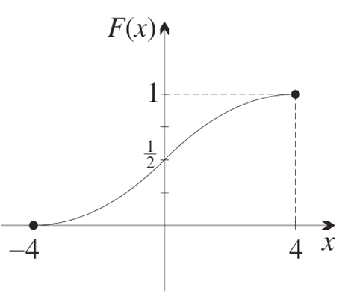
  - Find the CDF for $-4 ≤ x ≤ 0$, and the CDF for $0 ≤ x ≤ 4.$ Then sketch the whole CDF.

$$For -4 ≤ x ≤ 0:$$
$$F\left(x\right)= \int_{-4}^{x}{\frac{1}{16}\left(4 + t\right)}dt$$
$$= \frac{1}{32}{\left[{\left(4 + t\right)}^{2}\right]}_{-4}^{x}$$
$$= \frac{1}{32}\left({\left(4 + x\right)}^{2}- 0\right)= \frac{1}{32}{\left(4 + x\right)}^{2}$$
$$For 0 ≤ x ≤ 4, note F\left(0\right)=\frac{1}{2}:$$
$$F\left(x\right)=\frac{1}{2}+ \int_{0}^{x}{\frac{1}{16}\left(4 - t\right)}dt$$
$$=\frac{1}{2} - \frac{1}{32}{\left[{\left(4 - t\right)}^{2}\right]}_{0}^{x}$$
$$=\frac{1}{2}- \frac{1}{32}\left({\left(4 - x\right)}^{2}- 16\right)= 1 - \frac{1}{32}{\left(4 - x\right)}^{2}$$

Mastery
- Let $f(x)$ and $F(x) = e^{-kx}$, where $k =\frac{1}{8}ln2$, be the PDF and CDF respectively for the experiment of observing the time $x$ days that a radioactive nucleus survives before decaying.
  - Explain why the domain of possible values is the unbounded interval $[0, ∞).$
  - Find the formula for the PDF, and sketch the CDF and PDF.
  - Find the median, and show it is the half-life.
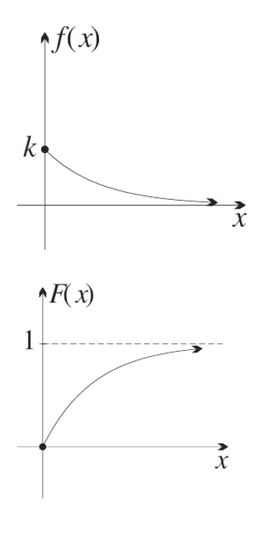
  - Find the probabilities that it decays on the first day and after the first day.

a) Decay can theoretically occur at any time, no matter how large, so the domain [0, ∞) is used.
b) CDF: $F(x) = 1 - e^{-kx}$
Differentiating: $f(x) = ke^{-kx}$

c) Set $F(x) = 0.5:$
$$1 - e^{-kx}=\frac{1}{2}$$
$$e^{-kx}=\frac{1}{2}$$
$$kx = ln2$$
$x =\frac{ln2}{k}=\frac{ln2}{\left(\frac{1}{8}\right)ln2}$ = 8 days, which is the half-life.
d) $P\left(X ≤ 1\right)= F\left(1\right)= 1 - e^{-k}≈ 0.083$
$$P\left(X > 1\right)= 1 - F\left(1\right)= e^{-k}≈ 0.917$$

  - Find the shaded area under the curve $y=$ $\frac{1}{x^{2}}$ over the interval $(1, ∞).$
  - Hence show that $y=$ $\frac{1}{x^{2}}$ for $x ≥ 1$, is a PDF, and find the CDF.
  - Sketch the PDF and CDF on two axes.
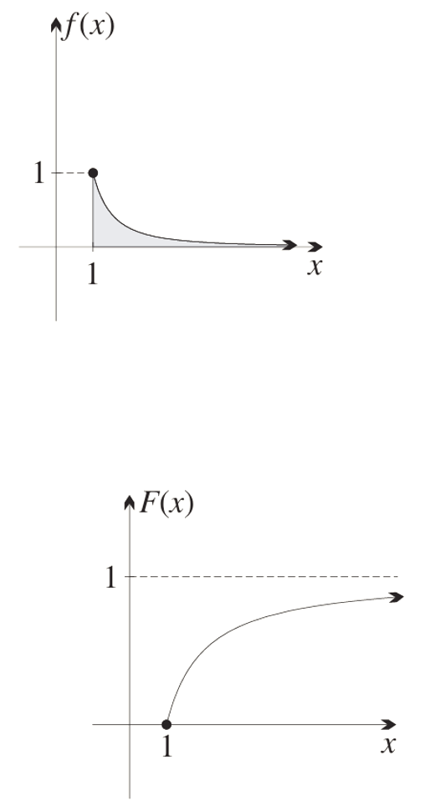
a) $\int_{1}^{∞}{\left(\frac{1}{x^{2}}\right)}dx = {\left[-\frac{1}{x}\right]}_{1}^{∞}= 0 - \left(-1\right)= 1$
(The limit of $-$ $\frac{1}{x}$ as $x → ∞$ is 0.)

b) $f\left(x\right)=\frac{1}{x^{2}}≥ 0$ for all $x ≥ 1$, and the integral over $[1, ∞)$ equals 1, so it is a PDF.
$$F\left(x\right)= \int_{1}^{x}{\left(\frac{1}{t^{2}}\right)}dt = {\left[-\frac{1}{t}\right]}_{1}^{x}= 1 -\frac{1}{x}$$

  - Find the mode of $f(x) = -\frac{3}{22}\left(x^{2}- 6x + 5\right)$ defined on [2, 4].
This is a concave down parabola, the turning point is the maximum
$$f^{'}\left(x\right)= -\frac{3}{22}\left(2x - 6\right)= 0$$
$x = 3$
Mode = 3.
  - Find the CDF.
$$F\left(x\right)= \int_{2}^{x}{\left(-\frac{3}{22}\left(t^{2}- 6t + 5\right)\right)}dt$$
$$= -\frac{3}{22}{\left[\frac{t^{3}}{3}- 3t^{2}+ 5t\right]}_{2}^{x}$$
$$= -\frac{1}{22}\left(x^{3}- 9x^{2}+ 15x - 2\right)$$
  - Find $P(X ≤ a)$ where $a$ is the mode.

$$P\left(X ≤ 3\right)= F\left(3\right)= -\frac{1}{22}\left(27 - 81 + 45 - 2\right)$$
$$= -\frac{1}{22}\left(-11\right)=\frac{1}{2}$$

- Athletes' finishing times varied between 3 and 7 minutes, represented by the continuous PDF $f(x) = \frac{1}{116}\left(x^{3}- 9x^{2}+ 24x + 1\right)$ on [3, 7].
  - Find the CDF.

$$F\left(x\right)= \int_{3}^{x}{\left(\frac{1}{116}\left(t^{3}- 9t^{2}+ 24t + 1\right)\right)}dt$$
$$= \frac{1}{464}\left(x^{4}- 12x^{3}+ 48x^{2}+ 4x - 201\right)$$

  - Find the probability that an athlete finishes:
    - in less than 5 minutes
$$P\left(X < 5\right)= F\left(5\right)=\frac{625 - 1500 + 1200 + 20 - 201}{464}=\frac{144}{464}=\frac{9}{29}$$
    - in 4 minutes or more
$$P\left(X ≥ 4\right)= 1 - F\left(4\right)= 1 -\frac{256 - 768 + 768 + 16 - 201}{464}= 1 -\frac{71}{464}=\frac{393}{464}$$
    - in between 4 and 5 minutes
$$P\left(4 ≤ X ≤ 5\right)= F\left(5\right)- F\left(4\right)=\frac{144}{464}-\frac{71}{464}=\frac{73}{464}$$
  - What is the most likely finishing time?
f'(x) = (1/116)(3x² − 18x + 24) = 0 → x² − 6x + 8 = 0 → x = 2 or x = 4. Only x = 4 is in [3, 7].
Check endpoints: f(3) = 19/116, f(4) = 17/116, f(7) = 71/116. Maximum at x = 7.
Mode = 7 minutes.

- A chicken wanders uniformly at random inside a circular enclosure of radius 6 m.
Let $X$ be its distance from the centre O.
  - Find the CDF, which is the probability of finding the chicken a distance of $x$ metres or less from the centre of the enclosure. $F(x) = P(X ≤ x).$
$$F\left(x\right)=\frac{area of inner circle}{area of whole circle}$$
$$=\frac{πx^{2}}{π × 6^{2}}$$
$$= \frac{1}{36}x^{2}, for 0 ≤ x ≤ 6$$

  - Find the probability of finding the chicken 2 metres or less from the centre of the enclosure.

$$F\left(2\right)=\frac{1}{36}\left(4\right)=\frac{1}{9}$$
  - Find the probability of finding the chicken between two to five metres from the centre of the circular enclosure.

$$P\left(chook is 2-5 m from centre\right)= F\left(5\right)- F\left(2\right)$$
$$= \left(\frac{1}{36}\right)\left(25 - 4\right)$$
$$=\frac{21}{25}$$
  - Use the CDF to find the probability of finding the chicken within 6 m of the centre of the enclosure.
$$F\left(6\right)=\frac{1}{36}{\left(6\right)}^{2}=1$$
Based on the context, this makes sense as the enclosure only has a radius of 6 m

  - Find the PDF.
PDF is the derivative of the CDF
$$f\left(x\right)=\frac{x}{18}$$

Median and Quartiles using the CDF

- Median and Quartiles using the CDF
The median is the value of $x$ for which $F\left(x\right)=0.5$.
The first quartile can be similarly found by $F\left(x\right)=0.25$ and the third quartile $F\left(x\right)=0.75$.

- Example Calculate median and quartiles using a CDF
The continuous random variable $X$ has CDF $F\left(x\right)=$ $\frac{x^{3}-1}{63}$ on $\left[1,4\right]$.
- Find the median  $$F\left(x\right)=\frac{1}{2} \\ \frac{x^{3}-1}{63}=\frac{1}{2} \\ x^{3}-1=\frac{63}{2} \\ x^{3}=\frac{65}{2} \\ x=\sqrt[3]{\frac{65}{2}}≈3.19$$ | - Find the first quartile $Q_{1}$  $$F\left(x\right)=\frac{1}{4} \\ \frac{x^{3}-1}{63}=\frac{1}{4} \\ x^{3}-1=\frac{63}{4} \\ x^{3}=\frac{67}{4} \\ x=\sqrt[3]{\frac{67}{4}}≈2.56$$

- Guided Practice
A continuous probability distribution has PDF $f\left(x\right)=$ $\frac{x^{4}}{11605}$ in the domain $\left[4,9\right]$.
Find the CDF and then find the median and third quartile.

Q2: 7.86
Q3: 8.51

- Key Ideas
- The median can be found from the ………………… ………………… ……………… by setting it equal to 0.5

Foundation
- For the CDF $F(x)=\frac{x^{2}}{64}$, find
  - the median Q₂
  - Q₁ and Q₃

$$Q_{2}=4\sqrt{2}$$
$Q_{1}$: $4$
$Q_{3}$: $4\sqrt{3}$.

- For the CDF $F(x)=\frac{x^{3}+8}{16}$, find
  - the median Q₂
  - Q₁ and Q₃
$$Q_{2}=0$$
$Q_{1}$: $-\sqrt[3]{4}$
$Q_{3}$: $\sqrt[3]{4}$.

- Find the median of each continuous random variable correct to 2 decimal places.
  - $f\left(x\right)=$ $\frac{3x^{2}}{511}$, interval $1 ≤ x ≤ 8$
$$F\left(x\right)=\frac{x^{3}- 1}{511}$$
$$\frac{m^{3}- 1}{511}=\frac{1}{2}$$
$$m^{3}= 256.5$$
$$m ≈ 6.35$$
  - $f\left(x\right)=$ $\frac{3{\left(x - 3\right)}^{2}}{16}$, domain [1, 5]
$$F\left(x\right)=\frac{{\left(x-3\right)}^{3}+ 8}{16}$$
$${\left(m-3\right)}^{3}= 0$$
$$m = 3$$
  - $f\left(x\right)=$ $\frac{{\left(2x - 1\right)}^{4}}{16105}$, domain [1, 6]
$$F\left(x\right)=\frac{{\left(2x-1\right)}^{5}- 1}{161050}$$
$${\left(2m-1\right)}^{5}= 80526$$
$$2m - 1 ≈ 9.58$$
$$m ≈ 5.29$$
  - $f\left(x\right)=$ $\frac{x{\left(x^{2}- 3\right)}^{3}}{3570}$, domain [2, 4]
$$F\left(x\right)=\frac{{\left(x^{2}-3\right)}^{4}- 1}{28560}$$
$${\left(m^{2}-3\right)}^{4}= 14281$$
$$m² - 3 ≈ 10.93$$
$$m ≈ 3.73$$

- For $f\left(x\right)=$ $\frac{x^{2}}{168}$ defined on $2 ≤ x ≤ 8$, find:
  - the median
$$F\left(x\right)=\frac{x^{3}- 8}{504}=0.5$$
$m³ = 260$
$$m ≈ 6.38$$
  - the 1st quartile
$$F\left(x\right)=\frac{x^{3}- 8}{504}=0.25$$
$$m³ = 134$$
$$m ≈ 5.12$$
  - the 3rd quartile
$$F\left(x\right)=\frac{x^{3}- 8}{504}=0.75$$
$$m^{3}= 386$$
$$m ≈ 7.28$$

  - the 67th percentile; 67% probability to get a value this number or less.
$$F\left(x\right)=\frac{x^{3}- 8}{504}=0.67$$
$$m³ = 345.68$$
$$m ≈ 7.02$$
  - the 8th decile; 80% probability to get a value this number or less.
$$F\left(x\right)=\frac{x^{3}- 8}{504}=0.8$$
$$m³ = 411.2$$
$$m ≈ 7.44$$
- For $f\left(x\right)=$ $\frac{x^{2}}{576}$ on $0≤x≤12$, find to 2 d.p.
  - the 20th percentile
  - the median
  - the 3rd quartile

$$F\left(x\right)=\frac{x^{3}}{1728}.$$
20th percentile: 7.02
Median: 9.52
3rd quartile: 10.90

Development
- Define $f\left(x\right)= \frac{3}{32}x\left(4 - x\right), 0 ≤ x ≤ 4.$
  - State the mode.
Mode = $2$. Graph is a concave down parabola with maximum at $x=2$.
  - Confirm $\int_{0}^{4}{f\left(x\right)}dx = 1.$
$$\frac{3}{32}\int_{0}^{4}{x}\left(4-x\right) dx=\frac{3}{32}{\left[2x^{2}-\frac{x^{3}}{3}\right]}_{0}^{4}$$
$$=\frac{3}{32}\left(32-\frac{64}{3}\right)$$
$$=1$$
  - Write down $P(X ≤ 2).$ What property of the curve allows this without integration?

$P(X≤2)=\frac{1}{2}$ by symmetry about $x=2$.
  - Evaluate $P(X ≤ 1)$ and $P(X > 1).$ Explain why they add to 1.

$$P(X≤1)=\frac{3}{32}{\left[2x^{2}-\frac{x^{3}}{3}\right]}_{0}^{1}=\frac{5}{32}$$
$$P(X>1)=1-\frac{5}{32}=\frac{27}{32}$$
They add to $1$ because total probability is $1$.
  - Evaluate $P(X ≤ 0.5)$ and $P(X ≥ 3.5).$ What do you notice?
$$P(X≤0.5)=\frac{3}{32}\left[2(0.25)-\frac{0.125}{3}\right]=\frac{3}{32}\left(\frac{11}{24}\right)=\frac{11}{256}$$
$P(X≥3.5)=$ $\frac{11}{256}$ by symmetry.
They are equal.
  - Find the CDF using $F\left(x\right)= \int_{0}^{x}{f\left(t\right)}dt.$
$$F\left(x\right)=\int_{0}^{x}{\frac{3}{32}}t\left(4-t\right) dt=\frac{3}{32}{\left[2t^{2}-\frac{t^{3}}{3}\right]}_{0}^{x}$$
$$=\frac{x^{2}(6-x)}{32}$$
  - Use the CDF to evaluate:
    - $P\left(X < 1.5\right)$
    - $P\left(1 < X < 1.5\right)$
    - $P\left(3 < X < 3.5\right)$
    - $P\left(2 < X < 2.5\right)$
$$i) F(1.5)=\frac{(2.25)(4.5)}{32}=\frac{81}{256}$$
$$ii) F(1.5)-F(1)=\frac{81}{256}-\frac{40}{256}=\frac{41}{256}$$
$iii)$ By symmetry = $P\left(0.5<X<1\right)=F\left(1\right)-F\left(0.5\right)$
$$=\frac{40}{256}-\frac{11}{256}=\frac{29}{256}$$
$$iv) F(2.5)-F(2)=\frac{(6.25)(3.5)}{32}-\frac{16}{32}=\frac{47}{256}$$

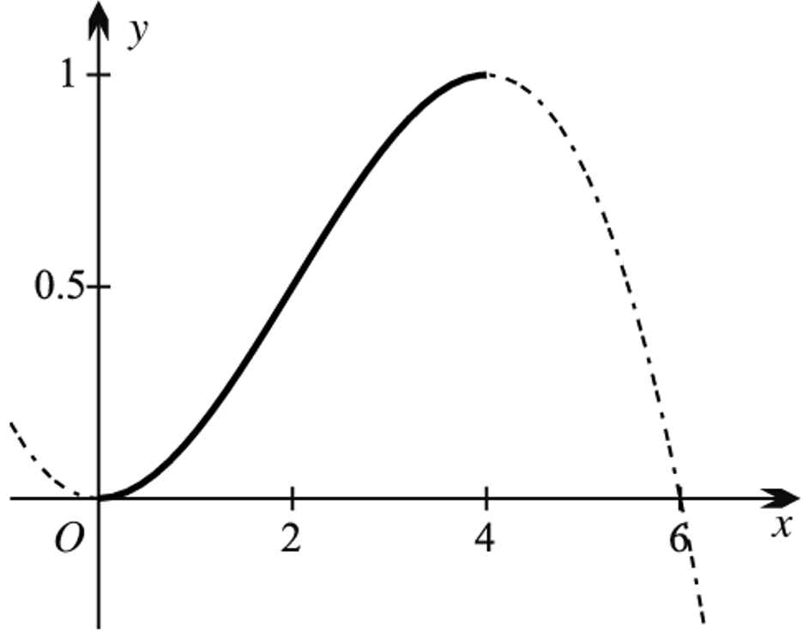
  - Graph the CDF.

  - Confirm $P(X < 2) = 0.5$using the CDF.
$$F(2)=\frac{4(4)}{32}=\frac{16}{32}=\frac{1}{2}$$
50% of data lie to the left of $x=2$.
  - Find Q₁ and Q₃ by solving $F(x) = 0.25$ and $F(x) = 0.75$.

$$Q_{1}≈1.3$$
$$Q_{3}≈2.7$$
- Define $f(x) = ce⁻ˣ, 0 ≤ x ≤ 1.$
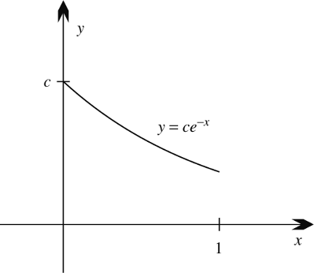
  - Sketch $y = f(x).$

  - Find $c$, given$f(x)$ is a PDF.

$$\int_{0}^{1}{c}e^{-x} dx=c\left(1-e^{-1}\right)=\frac{c(e-1)}{e}=1$$
$$c=\frac{e}{e-1}$$
  - Find the CDF.

$$F(x)=\frac{e}{e-1}\int_{0}^{x}{e^{-t}} dt=\frac{e}{e-1}(1-e^{-x})$$
  - Find a general equation for finding any percentile by setting $F\left(x\right)=p$
Set $F(x)=p$
$$e^{-x}=1-\frac{p(e-1)}{e}$$
$$x=log\left(\frac{e}{e-p(e-1)}\right)$$
  - Hence find Q₁, Q₂ and Q₃.
$$Q_{1}:\left(p=\frac{1}{4}\right): x=ln\left(\frac{4e}{3e+1}\right)$$
$$Q_{2}:\left(p=\frac{1}{2}\right): x=ln\left(\frac{2e}{e+1}\right)$$
$$Q_{3}:\left(p=\frac{3}{4}\right): x=ln\left(\frac{4e}{e+3}\right)$$

Expected Value and Variance

- Review
- Calculate expected value and variance from a discrete random distribution
The table below shows the monetary return for playing a game of chance at a casino.
Find the expected value $E\left(X\right)=ΣxP\left(x\right)$

$$x$$ | $$-\$10$$ | $$\$10$$ | $$\$90$$
$$P\left(x\right)$$ | $$\frac{3}{4}$$ | $$\frac{3}{13}$$ | $$\frac{1}{52}$$

$$-\$3.46$$

Find the variance $Var\left(X\right)=E\left(X^{2}\right)-μ^{2}=\sum{\left(x^{2}P\left(x\right)\right)}-μ^{2}$
and standard deviation $σ=\sqrt{VAR(X)}$

$$x$$ | $$-\$10$$ | $$\$10$$ | $$\$90$$
$$P\left(x\right)$$ | $$\frac{3}{4}$$ | $$\frac{3}{13}$$ | $$\frac{1}{52}$$

$241.86
$$σ=15.55$$

- Expected Value and Variance of Continuous Random Variables
Expected Value (mean)  Discrete:  $$E\left(X\right)=μ=\sum{xP\left(x\right)}$$  Continuous:  $$E\left(X\right)=μ=\int_{a}^{b}{xf\left(x\right)dx}$$ | Variance  Discrete:  $$\text{Var}\left(X\right)=E\left(X^{2}\right)-μ^{2}=\sum{\left(x^{2}P\left(x\right)\right)}-μ^{2}$$  Continuous:  $$\text{Var}\left(X\right)=E\left(X^{2}\right)-μ^{2}=\int_{a}^{b}{x^{2}f\left(x\right)dx}-μ^{2}$$

- Example Calculate expected value and variance for a PDF
The continuous random variable $X$ has PDF $f\left(x\right)=$ $\frac{3x^{2}}{8}$ on $\left[0,2\right]$.
Find the expected value.  $$E\left(X\right)=\int_{0}^{2}{x⋅\frac{3x^{2}}{8}}dx \\ =\int_{0}^{2}{\frac{3x^{3}}{8}}dx \\ ={\left[\frac{3x^{4}}{32}\right]}_{0}^{2} \\ =\frac{3}{32}\left(16-0\right) \\ =\frac{3}{2}$$ | Find the variance.  $$Var\left(X\right)=\int_{0}^{2}{x^{2}⋅\frac{3x^{2}}{8}}dx-μ^{2} \\ =\int_{0}^{2}{\frac{3x^{4}}{8}}dx-{\left(\frac{3}{2}\right)}^{2} \\ ={\left[\frac{3x^{5}}{40}\right]}_{0}^{2}-\frac{9}{4} \\ =\frac{3}{40}\left(32-0\right)-\frac{9}{4} \\ =\frac{3}{20}$$

- Guided Practice
The continuous random variable $X$ has PDF $f\left(x\right)=$ $\frac{x^{2}}{21}$ on $\left[1,4\right]$. Find $E(X)$ and $Var(X)$.

$$E\left(X\right)=\frac{85}{28}, Var\left(X\right)=\frac{2067}{3920}$$

Foundation
- A function is defined by $f\left(x\right)=\frac{1}{10}, 0 ≤ x ≤ 10.$
  - Show $f(x)$ is a valid PDF.
$$f(x)=\frac{1}{10}≥0$$
$$\int_{0}^{10}{\frac{1}{10}} dx=1$$
  - Calculate $E(X)$ using $E\left(X\right)= \int_{a}^{b}{xf\left(x\right)}dx.$
$$E\left(X\right)=\int_{0}^{10}{\frac{x}{10}} dx=\frac{1}{10}{\left[\frac{x^{2}}{2}\right]}_{0}^{10}$$
$$=5$$
  - Does $E(X)$ agree with your understanding of expected value as an average?

$E(X)=5$ is the midpoint of $[0,10]$, the expected average for a uniform distribution
  - Calculate $Var\left(X\right)= E\left(X^{2}\right)- {\left(E\left(X\right)\right)}^{2}$ then find $σ$ using $σ=\sqrt{Var}$

$$E\left(X^{2}\right)=\frac{1}{10}\int_{0}^{10}{x^{2}} dx=\frac{100}{3}$$
$$\text{Var}=\frac{100}{3}-25=\frac{25}{3}$$
$$σ=\frac{5}{\sqrt{3}}$$
- Define $f(x) = \frac{3}{2}x^{2},$ domain $[-1, 1].$
  - Confirm it is a valid PDF.
$$\int_{-1}^{1}{\frac{3}{2}}x^{2} dx=\frac{3}{2}{\left[\frac{x^{3}}{3}\right]}_{-1}^{1}=\frac{3}{2}\left(\frac{2}{3}\right)=1$$
$$f(x)≥0 as \frac{3}{2}x^{2}≥0$$
  - Find E(X).
$$E(X)=\frac{3}{2}\int_{-1}^{1}{x^{3}} dx=0$$
  - Find $Var(X)$ and $σ$.
$$E(X^{2})=\frac{3}{2}\int_{-1}^{1}{x^{4}} dx=\frac{3}{2}\left(\frac{2}{5}\right)=\frac{3}{5}$$
$$\text{Var}(X)=\frac{3}{5}-0=\frac{3}{5}$$
$$σ=\frac{\sqrt{15}}{5}$$
  - Calculate $\int_{μ-σ}^{μ+σ}{f\left(x\right)}dx$ to find the percentage of the population within one standard deviation of the mean.
$$P\left(-\frac{\sqrt{15}}{5}≤X≤\frac{\sqrt{15}}{5}\right)=\frac{3}{2}\int_{-\frac{\sqrt{15}}{5}}^{\frac{\sqrt{15}}{5}}{x^{2}} dx=3{\left[\frac{x^{3}}{3}\right]}_{0}^{\frac{\sqrt{15}}{5}}$$
$$={\left(\frac{\sqrt{15}}{5}\right)}^{3}≈0.46$$
so approximately $46\%$

- Find the percentage of the population within one standard deviation of the mean, to 2 s.f:
  - $f(x) = 2x$, domain [0, 1]
  - $f(x) = |x|$, domain [−1, 1]
  - $f(x) = \frac{3}{64}x^{2},$ domain [0, 4]

a) 63%
b) 50%
c) 67%

